Conceptual Design and Thermodynamic Analysis of a Two-Spool Turbofan Engine
Engineering Design Report
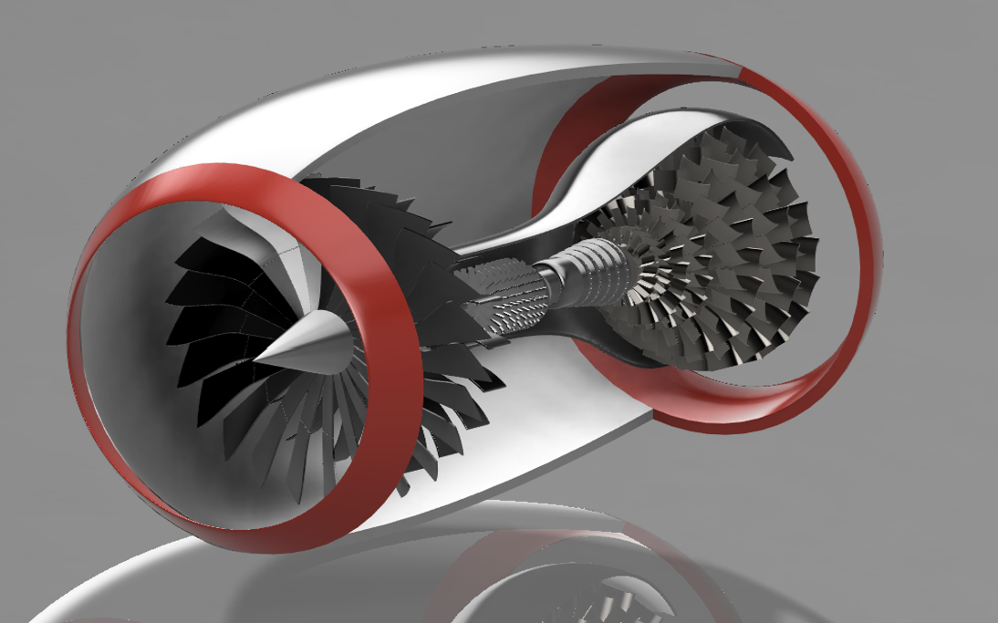

Project Name:
Turbofan Engine V1
Prepared By:
Rajnish Roshan
Software Used:
- Autodesk Fusion 360
- GNUU Octave
- Git & GitHub
Project Duration:
July 2026
Version:
Version 1.0

Declaration of Originality
I hereby declare that the work presented in this report, titled "Conceptual Design and Thermodynamic Analysis of a Two-Spool Turbofan Engine," is my own original engineering project.
The conceptual design, CAD models, engineering drawings, technical documentation, thermodynamic analysis, and supporting calculations presented in this report were developed independently as part of my personal aerospace engineering portfolio.
Where technical concepts, engineering principles, or publicly available references have been used, they have been appropriately acknowledged within the report.
This project has been prepared for educational, research, and portfolio purposes to demonstrate my understanding of aerospace engineering fundamentals, computer-aided design (CAD), engineering documentation, and thermodynamic analysis. It is a conceptual engineering study and is not intended to represent a certified, manufactured, or flight-approved aircraft engine.
I certify that this report is an accurate representation of the work completed by me.
Prepared By:
Rajnish Roshan
Date: July 2026
Location: Hamburg, Germany
Signature:
______________________________
Rajnish Roshan

Acknowledgement
I would like to express my sincere gratitude to everyone who has directly or indirectly contributed to the completion of this conceptual engineering project.
First and foremost, I thank God for providing me with the strength, patience, and determination to continue learning and improving throughout this project.
I am grateful to my family for their continuous encouragement and belief in my long-term vision of pursuing a career in aerospace engineering and building innovative aerospace technologies.
I would also like to acknowledge the engineers, educators, researchers, and the global aerospace community whose publicly available books, research papers, technical articles, educational videos, and engineering resources have helped me develop a stronger understanding of turbofan engine design, thermodynamics, aerodynamics, and mechanical engineering principles.
Special appreciation is extended to the developers of Autodesk Fusion 360, GNU Octave, and Git & GitHub for providing powerful engineering and software development tools that made the design, analysis, documentation, and version control of this project possible.
This project represents an important milestone in my personal engineering journey. It has significantly improved my understanding of aerospace propulsion systems, computer-aided design (CAD), engineering documentation, and fundamental thermodynamic analysis. More importantly, it has strengthened my problem-solving ability and reinforced my commitment to continuous learning and engineering excellence.
Finally, I acknowledge that this project is a conceptual engineering study developed for educational and portfolio purposes. It serves as a foundation for future work involving detailed analysis, simulation, optimization, manufacturing considerations, and experimental validation.
I look forward to applying the knowledge gained from this project to increasingly advanced aerospace engineering challenges in the future.

Rajnish Roshan
July 2026
Hamburg, Germany

Abstract
The objective of this project was to design, model, and document a conceptual two-spool turbofan engine using modern computer-aided design (CAD) techniques while applying fundamental aerospace engineering and thermodynamic principles.
The engine was developed entirely in Autodesk Fusion 360 and consists of the major components found in a conventional turbofan engine, including a fan, multi-stage axial compressor, combustion chamber, high-pressure turbine, low-pressure turbine, dual-spool shaft arrangement, exhaust nozzle, and nacelle. Throughout the design process, emphasis was placed on achieving a realistic engine architecture, maintaining proper component alignment, representing the functional architecture of a conventional two-spool turbofan engine, and understanding the functional relationship between individual engine sections.
In addition to the three-dimensional CAD model, this project includes engineering drawings, exploded assembly views, sectional views, high-quality rendered images, and a structured engineering design report. A simplified thermodynamic analysis will be performed using GNU Octave to estimate compressor performance, combustor temperature rise, turbine work, nozzle exit velocity, estimated thrust, and overall engine efficiency based on reasonable engineering assumptions.
The primary purpose of this project is educational and portfolio development. It demonstrates practical skills in aerospace component design, CAD modeling, engineering documentation, basic thermodynamic analysis, and technical communication. Although the engine is a conceptual design and has not been manufactured or experimentally validated, the project follows engineering design methodology and serves as a foundation for future studies involving computational fluid dynamics (CFD), finite element analysis (FEA), detailed performance simulations, and prototype development.
This project represents an important step in developing the engineering knowledge, practical skills, and professional portfolio required for future opportunities in the aerospace industry.

Keywords:

Turbofan Engine; Aerospace Engineering; Gas Turbine; CAD Design; Autodesk Fusion 360; Thermodynamics; GNU Octave; Aerospace Propulsion; Mechanical Design; Engineering Documentation

Project Objectives
The primary objective of this project was to design, model, and document a conceptual two-spool turbofan engine using modern computer-aided design (CAD) techniques while applying fundamental principles of aerospace engineering, thermodynamics, and mechanical design.
This project was undertaken as a personal engineering portfolio to develop practical design skills, improve technical understanding of gas turbine propulsion systems, and establish a strong foundation for future aerospace engineering projects.

Primary Objectives
- Design a complete conceptual two-spool turbofan engine using Autodesk Fusion 360.
- Develop realistic three-dimensional CAD models for all major engine components, including the fan, compressor, combustion chamber, turbines, shafts, nacelle, and exhaust nozzle.
- Understand the functional arrangement and interaction of turbofan engine components.
- Apply fundamental aerospace engineering and thermodynamic principles during the design process.
- Produce a professional engineering design report documenting the complete project.

Secondary Objectives
- Generate high-quality engineering renderings for technical documentation.
- Create exploded assembly views and sectional views to illustrate the internal engine architecture.
- Export professional engineering drawings for major components and the complete assembly.
- Perform a simplified thermodynamic performance analysis using GNU Octave, including compressor performance, combustor temperature rise, turbine work, nozzle exit velocity, and estimated thrust.
- Develop engineering plots and graphs to visualize engine performance.
- Publish the complete project, including CAD files, analysis scripts, drawings, documentation, and reports, in a well-organized GitHub repository.
- Strengthen engineering documentation, technical communication, and project management skills.

Project Scope
This project focuses on the conceptual design and engineering documentation of a two-spool turbofan engine. The scope includes three-dimensional CAD modeling, engineering drawings, rendering, and simplified thermodynamic analysis based on accepted engineering assumptions.
The project does not include detailed computational fluid dynamics (CFD), finite element analysis (FEA), manufacturing design, material optimization, combustion simulation, structural testing, or experimental validation. These aspects are identified as future development opportunities beyond the scope of this report.

Project Deliverables
Upon completion, this project will provide:
- A complete conceptual turbofan engine CAD model.
- Professional engineering documentation.
- Engineering drawings and rendered visualizations.
- Simplified thermodynamic analysis with supporting graphs.
- A structured GitHub repository containing all project files.
- A portfolio-quality engineering project demonstrating proficiency in conceptual aerospace design and technical documentation.

Introduction to Turbofan Engines
A turbofan engine is a modern air-breathing gas turbine engine widely used for commercial airliners, military transport aircraft, business jets, and many advanced military aircraft. It is designed to produce high thrust while maintaining improved fuel efficiency, lower noise levels, and greater overall performance compared with earlier turbojet engines.
Unlike a turbojet engine, which generates nearly all of its thrust from high-speed exhaust gases, a turbofan engine incorporates a large fan at the front of the engine. This fan accelerates a significant quantity of air around the engine core through a bypass duct. The bypass airflow contributes a substantial portion of the total thrust while reducing fuel consumption and engine noise.
A modern turbofan engine consists of two primary airflow paths:
- Bypass Flow: Air that passes around the engine core and produces efficient thrust through the fan.
- Core Flow: Air that passes through the compressor, combustion chamber, turbine, and exhaust nozzle, where energy is extracted from fuel combustion.
This combination of bypass and core airflow enables turbofan engines to achieve significantly higher propulsive efficiency than conventional turbojet engines, making them the preferred propulsion system for most modern aircraft.

Basic Operating Principle
The operation of a turbofan engine follows the Brayton Cycle, a continuous thermodynamic cycle consisting of four principal processes:
- Air Intake: Ambient air enters the engine through the inlet and is divided into bypass and core airflow.
- Compression: The compressor increases the pressure and temperature of the incoming air before it enters the combustion chamber.
- Combustion: Fuel is injected and burned at nearly constant pressure, producing high temperature, high energy gases.
- Expansion: The hot gases expand through turbine stages that extract energy to drive the compressor and fan before exiting through the nozzle to produce thrust.
This continuous process enables sustained engine operation while converting chemical energy from fuel into mechanical power and useful propulsive thrust.

Major Components of a Turbofan Engine
The principal components of a two-spool turbofan engine include:

Fan
The fan is the first rotating component of the engine and accelerates a large mass of air. It generates a significant portion of the total engine thrust while supplying airflow to both the bypass duct and engine core.

Compressor
The compressor consists of multiple axial stages that progressively increase the pressure of the incoming air. Higher pressure improves combustion efficiency and overall engine performance.

Combustion Chamber
Compressed air is mixed with fuel and ignited within the combustion chamber. The resulting high-temperature gases provide the energy required to drive the turbine stages.

High-Pressure Turbine (HPT)
The high-pressure turbine extracts sufficient energy from the hot gases to drive the high-pressure compressor through the high-pressure shaft.

Low-Pressure Turbine (LPT)
The low-pressure turbine extracts additional energy to drive the fan and low-pressure compressor through the low-pressure shaft.

Exhaust Nozzle
The nozzle accelerates the remaining exhaust gases to high velocity, producing additional thrust according to Newton's Third Law of Motion.

Nacelle
The nacelle forms the aerodynamic outer casing of the engine. It protects internal components, guides airflow, reduces drag, and contributes to the structural integrity of the propulsion system.

Advantages of Turbofan Engines
Compared with turbojet engines, turbofan engines offer several significant advantages:
- Higher propulsive efficiency
- Lower specific fuel consumption
- Reduced engine noise
- Greater thrust at subsonic flight speeds
- Improved reliability
- Better environmental performance
- Longer operational life
These characteristics make turbofan engines the dominant propulsion system for commercial aviation and many modern military aircraft.

Relevance to This Project
The conceptual engine developed in this report is based on the architecture of a two-spool axial-flow turbofan engine. The design incorporates the fundamental components found in modern gas turbine propulsion systems, including a fan, multi-stage compressor, combustion chamber, high- and low-pressure turbine stages, dual concentric shafts, exhaust nozzle, and aerodynamic nacelle.
While the model presented is intended for educational and portfolio purposes rather than certified operation, the overall configuration reflects accepted aerospace engineering principles and serves as a foundation for future work involving detailed thermodynamic analysis, computational fluid dynamics (CFD), finite element analysis (FEA), and experimental validation.
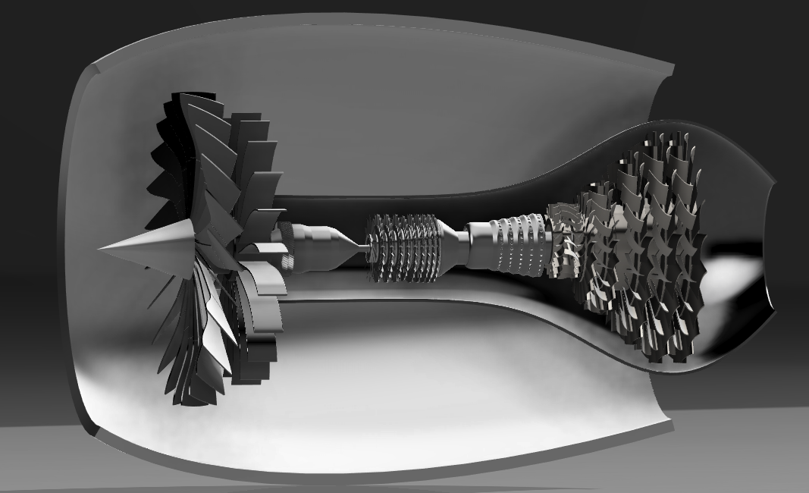
[Figure 6.1:Cross-sectional CAD model of the conceptual two-spool turbofan engine showing the fan, compressor, combustion chamber, turbine stages, concentric shafts, and exhaust nozzle.]

Design Requirements

Prior to developing the conceptual turbofan engine, a structured set of engineering requirements was established to define the objectives, functionality, mechanical arrangement, and documentation goals of the project. These requirements guided the CAD development process and ensured that the final design maintained a realistic configuration representative of a modern two-spool turbofan engine while remaining suitable for educational and engineering portfolio purposes.

1. Design Philosophy
The primary objective of this project was to develop a conceptual two-spool turbofan engine using modern computer-aided design (CAD) techniques while following the fundamental architecture of contemporary gas turbine engines.
Rather than replicating a specific commercial engine, the design was intended to provide a clear understanding of engine configuration, component integration, mechanical arrangement, and propulsion system architecture. Throughout the development process, emphasis was placed on creating a clean, modular, and mechanically consistent design suitable for engineering documentation and future analytical studies.

2. Project Requirements
The conceptual engine was developed according to the following engineering requirements:
- Develop a complete three-dimensional CAD model of a two-spool turbofan engine.
- Include all major propulsion system components within a single integrated assembly.
- Maintain proper axial alignment between rotating and stationary components.
- Design components that accurately represent the functional arrangement of a modern turbofan engine.
- Produce engineering renderings, exploded views, sectional views, and orthographic drawings for technical documentation.
- Prepare the model for simplified thermodynamic analysis using GNU Octave.
- Organize the complete project into a professional engineering portfolio supported by structured documentation and version control.

3. Functional Requirements
The conceptual engine should demonstrate the following functional characteristics:
- Efficient airflow path from inlet to exhaust.
- Multi-stage axial compression system.
- Separate fan and engine core airflow representation.
- Dual concentric shaft arrangement representing low-pressure and high-pressure spools.
- High-pressure combustion chamber positioned between compressor and turbine.
- Multi-stage turbine assembly capable of driving the compressor and fan conceptually.
- Aerodynamic nacelle enclosing the propulsion system.
- Exhaust nozzle for acceleration of combustion gases.

4. Mechanical Design Requirements
The mechanical configuration was developed to satisfy several engineering considerations:
- Smooth transition between engine sections.
- Proper concentric alignment of all rotating components.
- Uniform axial spacing between compressor and turbine stages.
- Modular construction allowing individual component development and future modification.
- Realistic proportional dimensions based on modern turbofan engine architecture.
- Simplified geometry suitable for educational analysis while preserving overall engineering realism.

5. CAD Modeling Requirements
The CAD model was created with the following objectives:
- Parametric modeling using Autodesk Fusion 360.
- Individual modeling of major engine components before final assembly.
- High-quality rendered visualization.
- Cross-sectional visualization of internal architecture.
- Exploded assembly representation.
- Engineering drawing generation.
- Export compatibility for STEP, STL, and Fusion 360 project files.

6. Design Constraints
The following constraints were considered during the conceptual development:
- The project is intended for educational and engineering portfolio purposes only.
- No detailed aerodynamic optimization was performed.
- Blade geometry was simplified for efficient CAD modeling.
- Material selection and structural analysis were not included in this phase.
- Manufacturing tolerances were not considered.
- The thermodynamic performance analysis is based on engineering assumptions rather than experimental testing.
- The design does not represent a certified or production-ready aircraft engine.

7. Engineering Design Goals
The completed conceptual engine should satisfy the following goals:
- Demonstrate understanding of turbofan engine architecture.
- Illustrate correct arrangement of propulsion system components.
- Provide a realistic engineering model suitable for documentation.
- Serve as the foundation for thermodynamic calculations and future computational analysis.
- Form a professional aerospace engineering portfolio project demonstrating CAD, documentation, and analytical skills.
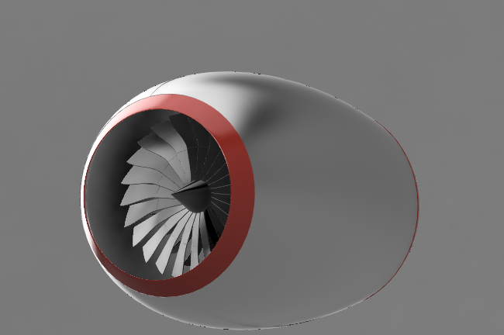
The design requirements presented in this chapter formed the engineering foundation of the project and influenced every stage of the CAD development process. By establishing clear functional, mechanical, and documentation objectives before modeling began, the project maintained consistency throughout the design process and provides a suitable basis for the detailed component descriptions presented in the following chapters.

[Figure 7.1: Final conceptual two-spool turbofan engine developed in Autodesk Fusion 360 showing the complete external nacelle configuration and overall engine architecture.]

Overall Engine Architecture

8.1 Introduction
The conceptual engine developed in this project follows the architecture of a modern two-spool axial-flow turbofan engine. The overall configuration was selected to represent the fundamental layout of contemporary aircraft propulsion systems while remaining suitable for educational study, engineering documentation, and future analytical work.
The engine consists of a fan section, a multi-stage axial compressor, a combustion chamber, high- and low-pressure turbine stages, dual concentric shafts, an exhaust nozzle, and an aerodynamic nacelle. These components are arranged sequentially along a common longitudinal axis to provide a continuous airflow path from the engine inlet to the exhaust nozzle.
Throughout the CAD development process, emphasis was placed on maintaining a realistic component arrangement, concentric alignment, and modular construction to simplify future modifications and engineering analysis.

8.2 Overall Configuration
The engine adopts a conventional front-to-rear layout commonly used in modern turbofan propulsion systems.
The major components are arranged in the following sequence:
- Air Intake
- Fan Assembly
- Multi-Stage Axial Compressor
- Combustion Chamber
- High-Pressure Turbine
- Low-Pressure Turbine
- Exhaust Nozzle
This arrangement enables the engine to follow the basic Brayton Cycle while maintaining a logical mechanical connection between the compressor and turbine through the dual-spool shaft system.

8.3 Airflow Path
The airflow through the engine follows two distinct paths:

Bypass Airflow
A portion of the incoming air is accelerated by the fan and directed around the engine core through the bypass region. Although this conceptual model does not include a fully developed bypass duct, the nacelle geometry represents the external airflow path typically found in modern turbofan engines.

Core Airflow
The remaining airflow enters the engine core where it undergoes successive compression, combustion, expansion through turbine stages, and final acceleration through the exhaust nozzle.
This arrangement reflects the operating principle of high-bypass turbofan engines while maintaining a simplified conceptual configuration.

8.4 Two-Spool Arrangement
The engine incorporates a dual concentric shaft configuration, representing both the low-pressure and high-pressure spool systems.
The Low-Pressure Spool (LP Spool) conceptually connects:
- Fan
- Low-Pressure Compressor
- Low-Pressure Turbine
The High-Pressure Spool (HP Spool) conceptually connects:
- High-Pressure Compressor
- High-Pressure Turbine
Separating the rotating assemblies into two independently driven spool systems improves compressor efficiency and reflects the configuration used in many modern turbofan engines.
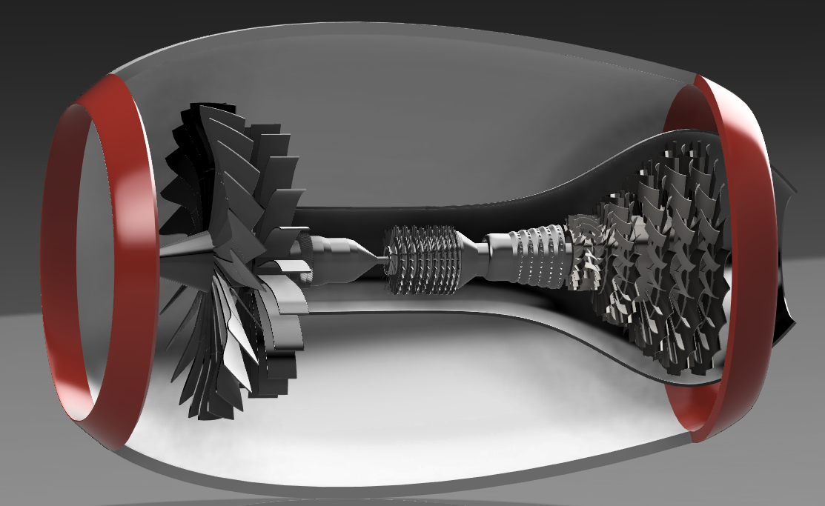

[Figure 8.1: Cross-sectional view of the conceptual two-spool turbofan engine illustrating the arrangement of the major propulsion system components.]

8.5 Engine Layout Philosophy
Rather than reproducing a specific commercial aircraft engine, the objective of this project was to develop a mechanically consistent conceptual architecture that clearly demonstrates the functional relationship between each propulsion system component.
The design emphasizes:
- Modular component development
- Proper axial alignment
- Simplified manufacturing geometry
- Engineering clarity
- Educational value
- Expandability for future CFD, FEA, and thermodynamic analysis
This approach provides a strong engineering foundation for subsequent subsystem design and performance evaluation.

8.6 Summary
The overall architecture successfully integrates all major components of a modern two-spool turbofan engine into a single CAD assembly while maintaining mechanical consistency and a logical propulsion system layout.
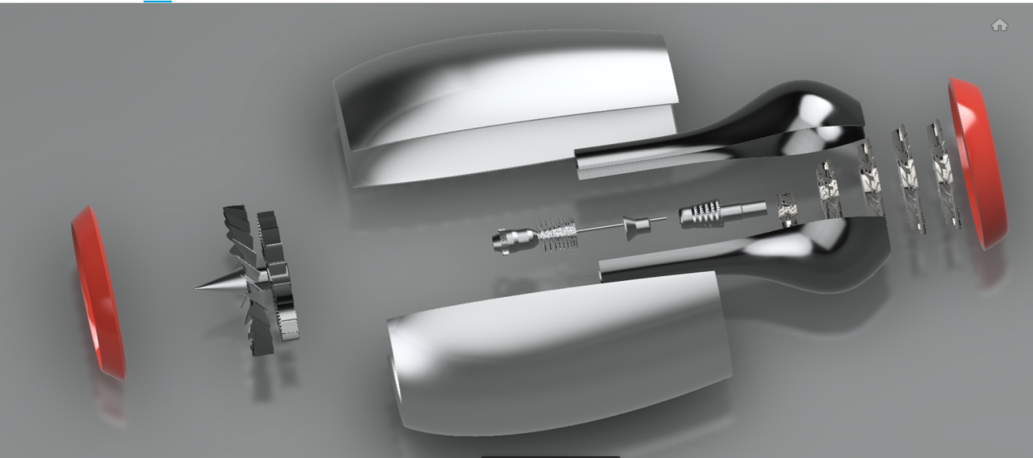
The modular design philosophy adopted throughout the project enables future improvements such as optimized blade geometry, detailed aerodynamic analysis, structural evaluation, and prototype development.

[Figure 8.2: Exploded CAD assembly illustrating the modular construction and component arrangement of the conceptual turbofan engine.]

Fan Design

9.1 Introduction
The fan is the foremost component of a turbofan engine and serves as the primary air-moving device during engine operation. It accelerates a large mass of incoming air while dividing the airflow into two separate paths: the bypass stream surrounding the engine core and the core stream entering the compressor. In modern high-bypass turbofan engines, the fan is responsible for producing the majority of the engine's thrust while also improving propulsive efficiency and reducing fuel consumption.
The fan developed for this conceptual project was designed to represent the overall geometry and functional arrangement of a modern aircraft turbofan engine. Rather than replicating an existing commercial design, the objective was to create a mechanically consistent, visually realistic, and educationally valuable component suitable for integration into the complete engine assembly and subsequent engineering analysis.

9.2 Design Objectives
The fan assembly was designed to satisfy the following engineering objectives:
- Represent the appearance and functionality of a modern turbofan engine fan.
- Produce a mechanically balanced and symmetrical rotor assembly.
- Maintain proper concentric alignment with the low-pressure shaft.
- Ensure smooth airflow entry into the engine core.
- Create a modular CAD component that can be independently modified.
- Provide a realistic front-end appearance for rendering and technical documentation.
- Serve as the first stage of the conceptual propulsion system.

9.3 Fan Configuration
The conceptual fan consists of the following major elements:
- Fan blades: Twenty-four blades arranged uniformly around the hub to represent a modern high-bypass turbofan configuration.
- Fan hub: Central rotating structure supporting the blades while transmitting torque from the low-pressure shaft.
- Spinner: Aerodynamically shaped nose cone positioned at the center of the fan to reduce inlet flow disturbances and guide airflow smoothly into the engine.
- Rotor assembly: The fan, hub, and spinner together form the rotating front-stage assembly connected to the low-pressure spool.
The final configuration emphasizes simplicity, mechanical consistency, and visual realism while remaining suitable for educational engineering studies.

9.4 Engineering Considerations
Several engineering principles guided the design of the fan assembly:
- Uniform blade spacing around the rotor to achieve rotational symmetry.
- Concentric alignment between the fan hub and engine centerline.
- Simplified blade geometry to facilitate efficient CAD modeling.
- Smooth aerodynamic transition between the spinner, hub, and blades.
- Modular construction allowing future optimization of blade geometry without redesigning the complete engine.
- Proportional dimensions selected to maintain realistic relationships with the compressor and nacelle.
Although the blade profiles are simplified compared with production aircraft engines, the overall configuration accurately represents the structural layout and functional purpose of a turbofan fan assembly.

9.5 CAD Modeling Procedure
The fan assembly was modeled using Autodesk Fusion 360 through a structured parametric workflow. The design process began with preliminary hand sketches in which blade dimensions, angular orientation, extrusion distances, and loft profiles were established. These sketches served as the basis for creating the CAD geometry.
Individual blade profiles were created and refined using sketch constraints and dimensional parameters. Three-dimensional blade geometry was generated using extrusion, loft, and fillet operations to obtain smooth aerodynamic surfaces. After completing a single blade, a circular pattern was applied to produce the complete 24-blade rotor assembly. The hub and spinner were modeled separately and assembled concentrically to form the final fan module.
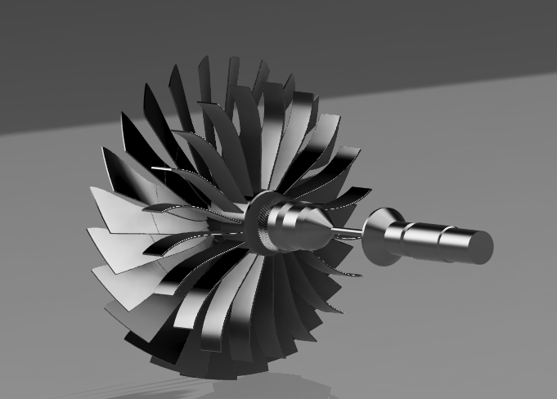
This workflow ensured consistent geometry, simplified future modifications, and maintained compatibility with the overall engine assembly.

Figure 9.1. Isometric CAD rendering of the conceptual turbofan fan assembly illustrating the 24-blade rotor, aerodynamic spinner, hub, and shaft connection integrated with the low-pressure spool.]

9.6 Summary
The fan assembly successfully fulfills the design objectives established for this conceptual turbofan engine. The component demonstrates proper rotor symmetry, modular construction, and realistic integration with the low-pressure spool while providing a visually representative model of a modern turbofan fan. The completed design forms the foundation of the propulsion system and provides the inlet airflow required for the downstream compression process.
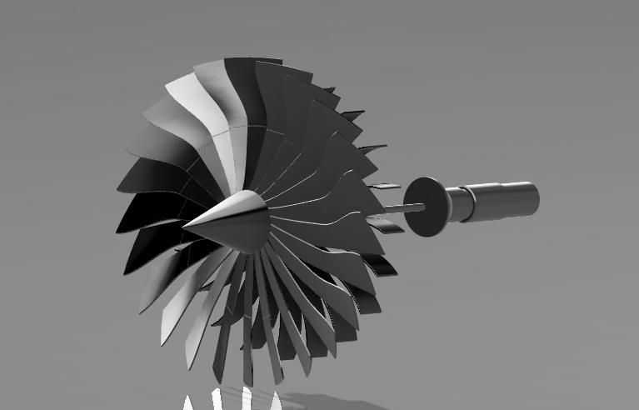

[Figure 9.2. Isometric CAD rendering of the conceptual turbofan fan assembly illustrating the 24-blade rotor, aerodynamic spinner, hub, and shaft connection integrated with the low-pressure spool.]

Multi-Stage Axial Compressor Design

10.1 Introduction
The axial compressor is one of the most critical components of a turbofan engine. Its primary function is to progressively increase the pressure of the incoming air before it enters the combustion chamber. Modern aircraft gas turbine engines employ multi-stage axial compressors because a single rotor stage cannot achieve the required pressure ratio efficiently.
The compressor developed for this conceptual project follows the architecture of a modern two-spool turbofan engine and consists of multiple alternating rotor and stator stages arranged along a common axis. Throughout the design process, emphasis was placed on maintaining mechanical consistency, realistic stage arrangement, and modular construction while creating a visually representative model suitable for engineering documentation and conceptual thermodynamic analysis.
Rather than reproducing a specific commercial compressor, the objective was to develop a conceptual design that demonstrates the fundamental operating principles and structural arrangement of a contemporary axial-flow compressor.

10.2 Design Objectives
The compressor assembly was developed to satisfy the following engineering objectives:
- Develop a realistic multi-stage axial compressor representative of modern turbofan engines.
- Progressively compress airflow through multiple rotor and stator stages.
- Design stage-specific rotor assemblies with varying diameters, blade geometries, and blade quantities.
- Maintain concentric alignment of all rotating and stationary components.
- Create a modular compressor suitable for integration within the complete engine assembly.
- Produce high-quality CAD models for renderings, exploded views, cross-sectional illustrations, and engineering drawings.
- Prepare the assembly for future thermodynamic analysis and conceptual performance evaluation.

10.3 Compressor Configuration
The conceptual compressor consists of ten axial rotor stages arranged sequentially along the high-pressure shaft to represent the high-pressure compressor of a modern two-spool turbofan engine. Between each rotor stage, stationary stator vanes are positioned to redirect the airflow before it enters the following rotor stage.
Each rotor stage was individually designed with its own diameter, blade geometry, and blade quantity to represent the progressive reduction in compressor annulus area and the increasing compression of the airflow toward the combustion chamber. This stage-specific approach produces a realistic visual representation of a multi-stage axial compressor while maintaining a modular and mechanically consistent architecture.
The stator assemblies employ a standardized blade geometry, diameter, and blade quantity throughout the compressor. This intentional simplification reduces CAD modeling complexity while preserving the alternating rotor–stator configuration characteristic of modern axial compressors.
The complete compressor is concentrically aligned along the high-pressure shaft and provides a continuous airflow path from the engine inlet to the combustion chamber.

10.4 Rotor Stage Specifications
This section will explain:
- Rotor 1
- Rotor 2
- Rotor 3
- Rotor 4
- Rotor 5
- Rotor 6
- Rotor 7
- Rotor 8
- Rotor 9
- Rotor 10
Rotor Stage | Rotor Diameter (mm) | Rotor Blade Count
1 | 420.000mm | 64
2 | 395.556mm | 80
3 | 371.112mm | 32
4 | 346.668mm | 35
5 | 322.224mm | 32
6 | 322.224mm | 30
7 | 297.780mm | 18
8 | 273.336mm | 16
9 | 248.892mm | 15
10 | 224.448mm | 14
The rotor diameters progressively decrease along the compressor axis while blade geometry and blade quantity vary from stage to stage in order to represent the changing flow conditions within a conceptual multi-stage axial compressor.

10.5 Rotor Design Methodology
The compressor rotor assembly was developed through an iterative engineering design process beginning with preliminary hand sketches and dimensional planning before implementation in Autodesk Fusion 360. This workflow enabled progressive refinement of each rotor stage while maintaining consistency throughout the compressor assembly.
Unlike the stator assemblies, each compressor rotor stage was individually designed to represent the changing geometric characteristics of a modern axial compressor. Rotor diameters, blade geometries, and blade quantities were varied from stage to stage to illustrate the gradual reduction in compressor flow area and the progression of airflow toward the combustion chamber.
The development process emphasized accurate component alignment, modular construction, and ease of future modification while producing a realistic conceptual representation of a multi-stage axial compressor.

10.5.1 Preliminary Engineering Sketches
Prior to three-dimensional modeling, each rotor stage was planned using hand-drawn engineering sketches. These sketches defined the principal design parameters required for CAD development, including:
- Rotor diameter for each compressor stage.
- Blade profile geometry.
- Blade inclination and orientation.
- Extrusion distances.
- Offset dimensions.
- Loft profiles.
- Circular pattern quantities.
- Axial positioning along the compressor shaft.
This preliminary design phase provided a structured framework that simplified the subsequent CAD modeling process and reduced design inconsistencies between stages.

10.5.2 CAD Development Process
Each compressor rotor was modeled individually using Autodesk Fusion 360 through a structured parametric workflow consisting of the following steps:
- Creation of the rotor hub.
- Development of the blade profile from engineering sketches.
- Generation of three-dimensional blade geometry using extrusion and loft operations.
- Application of fillets and geometric refinements.
- Creation of complete rotor stages using circular pattern features.
- Assembly of each rotor concentrically about the compressor centerline.
- Sequential integration of all ten rotor stages into the complete compressor assembly.
This methodology enabled every rotor stage to maintain its individual geometric characteristics while preserving overall mechanical alignment and modular construction.
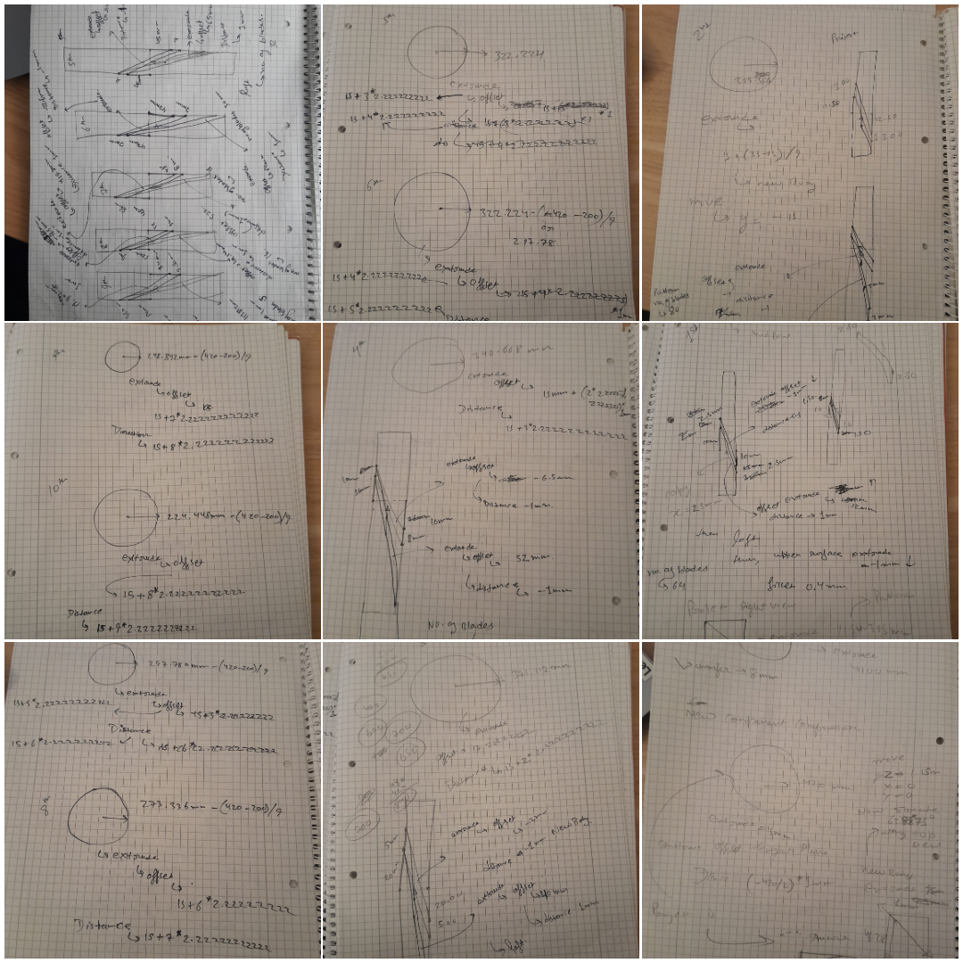
[Figure 10.1: Preliminary engineering sketches used during the conceptual development of the compressor rotor stages. The sketches define stage diameters, blade profiles, extrusion distances, circular pattern quantities, and other geometric parameters that guided the CAD modeling process in Autodesk Fusion 360.]

The stage-specific design methodology adopted throughout the compressor development provided a systematic approach for generating individual rotor stages while maintaining compatibility with the overall engine architecture. The resulting assembly reflects the progressive geometric changes characteristic of modern axial compressors and establishes the foundation for the subsequent stator arrangement and complete compressor integration.

10.6 Introduction(Stator)
In an axial compressor, the stator assemblies are stationary blade rows positioned between successive rotor stages. Their primary function is to redirect the airflow leaving each rotor, reduce rotational swirl, and provide an appropriate flow direction for the following rotor stage. By converting a portion of the air's kinetic energy into static pressure, the stators contribute significantly to the overall compression process.
The stator assemblies developed for this conceptual compressor follow the conventional alternating rotor–stator configuration employed in modern axial-flow compressors while maintaining a simplified geometry suitable for engineering documentation and conceptual design studies.

10.6.1 Design Objectives
The stator assemblies were developed to satisfy the following engineering objectives:
- Represent the stationary vane assemblies found in modern axial compressors.
- Redirect airflow between successive rotor stages.
- Maintain concentric alignment with the compressor centerline.
- Provide a modular component suitable for repeated implementation throughout the compressor assembly.
- Simplify CAD development while preserving realistic compressor architecture.
- Integrate mechanically with the complete compressor assembly.

10.6.2 Stator Configuration
Unlike the compressor rotors, which were individually designed for each stage, the stator assemblies utilize a common blade geometry, diameter, and blade quantity throughout the compressor.
This standardized configuration was intentionally selected to reduce CAD modeling complexity while preserving the alternating rotor–stator arrangement characteristic of multi-stage axial compressors. Although production aircraft engines typically employ stage-specific stator geometries optimized for local aerodynamic conditions, such optimization was considered beyond the scope of this conceptual engineering project.
Each stator assembly is positioned concentrically between adjacent rotor stages to guide the airflow toward the subsequent rotor while maintaining the overall structural continuity of the compressor.

10.6.3 Engineering Considerations
The stator configuration was developed according to the following design considerations:
- Uniform blade geometry throughout the compressor.
- Constant blade quantity for all stator stages.
- Constant outer diameter.
- Concentric alignment with the compressor centerline.
- Simplified modular construction.
- Mechanical compatibility with all rotor stages.
- Ease of future modification and aerodynamic optimization.
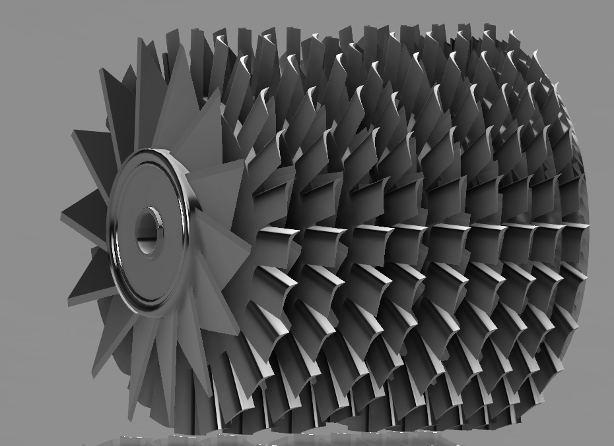

[Figure 10.2: Isometric CAD rendering of the conceptual multi-stage axial compressor illustrating the complete rotor–stator arrangement, progressive reduction in rotor diameter, and overall axial compressor architecture]

10.7 Summary
The completed compressor assembly successfully demonstrates the structural arrangement of a modern multi-stage axial compressor through progressive rotor sizing and alternating rotor–stator stages. Although simplified for conceptual engineering purposes, the model accurately represents the architecture, modular construction, and airflow progression of a contemporary high-pressure compressor while providing a solid foundation for subsequent combustor integration and future thermodynamic analysis.
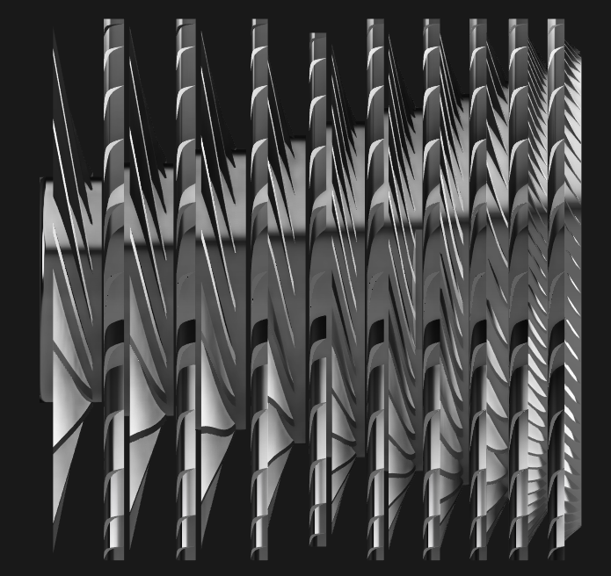
[Figure 10.3: Side-view CAD rendering of the conceptual multi-stage axial compressor illustrating the axial arrangement of rotor and stator stages, progressive reduction in rotor diameter, and airflow path toward the combustion chamber.]

11. Combustion Chamber Design
11.1 Introduction
The combustion chamber is the core energy-generation component of a turbofan engine. Its primary function is to mix compressed air from the high-pressure compressor with fuel and sustain a stable combustion process, thereby producing high-temperature, high-energy gases that drive the turbine stages.
Modern aircraft gas turbine engines employ highly optimized annular combustion chambers capable of achieving efficient fuel-air mixing, controlled flame stabilization, and uniform temperature distribution at the turbine inlet. These characteristics are essential for maximizing engine efficiency while protecting downstream turbine components from excessive thermal loading.
The combustion chamber developed for this conceptual turbofan project follows the general architecture of a modern annular combustor. Rather than reproducing a specific commercial engine, the objective was to develop a mechanically consistent conceptual design that accurately demonstrates the functional relationship between the compressor, combustor, and turbine while remaining suitable for engineering documentation and future thermodynamic analysis.

11.2 Design Objectives
The combustion chamber assembly was developed to satisfy the following engineering objectives:
- Represent the general architecture of a modern annular combustion chamber.
- Receive compressed airflow directly from the high-pressure compressor.
- Provide an enclosed combustion volume suitable for conceptual fuel-air mixing.
- Maintain concentric alignment with the compressor and turbine centerline.
- Create a modular CAD component suitable for independent modification.
- Provide realistic geometry for engineering documentation and rendering.
- Establish a foundation for future combustion and thermodynamic analysis.
11.3 Combustion Chamber Configuration
The conceptual combustion chamber consists of the following primary components:
- Outer combustion casing.
- Inner combustion liner.
- Annular combustion volume.
- Compressor discharge interface.
- Turbine inlet transition section.
- Central engine axis for concentric assembly.
The combustion chamber assembly was designed to provide a smooth aerodynamic and structural transition between the compressor outlet and turbine inlet while maintaining concentric alignment and modular integration throughout the engine. Although simplified compared with production aircraft combustors, the configuration accurately represents the structural layout and functional purpose of an annular combustion system suitable for conceptual engineering studies.
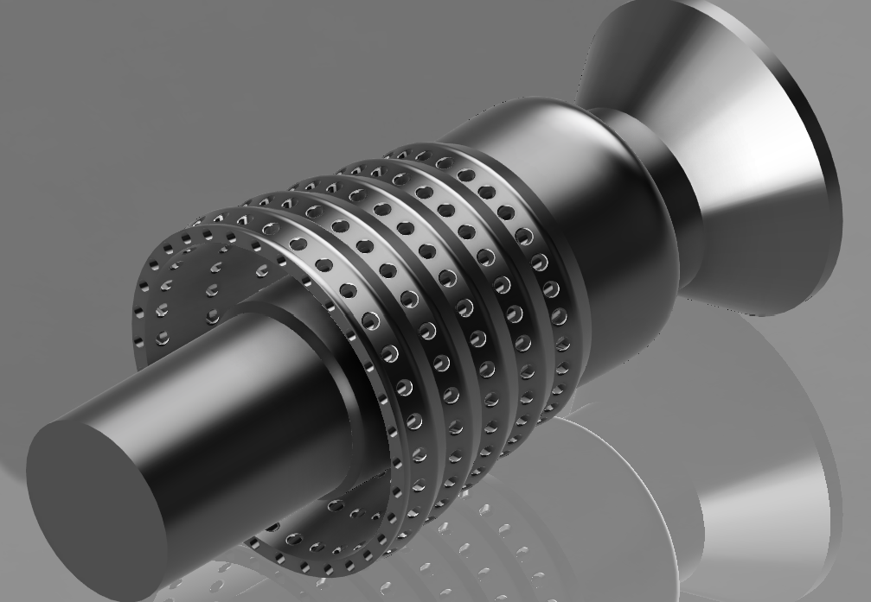

[Figure 11.1: Isometric CAD rendering of the conceptual annular combustion chamber illustrating the perforated combustion liner, outer casing, transition section, and modular configuration designed for integration between the compressor and turbine assemblies.]

11.4 Preliminary Engineering Sketches
Before the three-dimensional CAD model was created, the combustion chamber geometry was developed through a series of hand-drawn engineering sketches. These sketches established the principal dimensions, construction sequence, and geometric relationships required for the CAD model while allowing rapid refinement of the conceptual design before implementation in Autodesk Fusion 360.
The preliminary sketches defined:
- Overall combustion chamber profile.
- Inner and outer liner geometry.
- Annular combustion volume.
- Compressor outlet transition.
- Turbine inlet transition.
- Offset planes and reference geometry.
- Loft and revolve profiles.
- Hole pattern layout for the combustion liner.
- Principal dimensions for subsequent CAD construction.
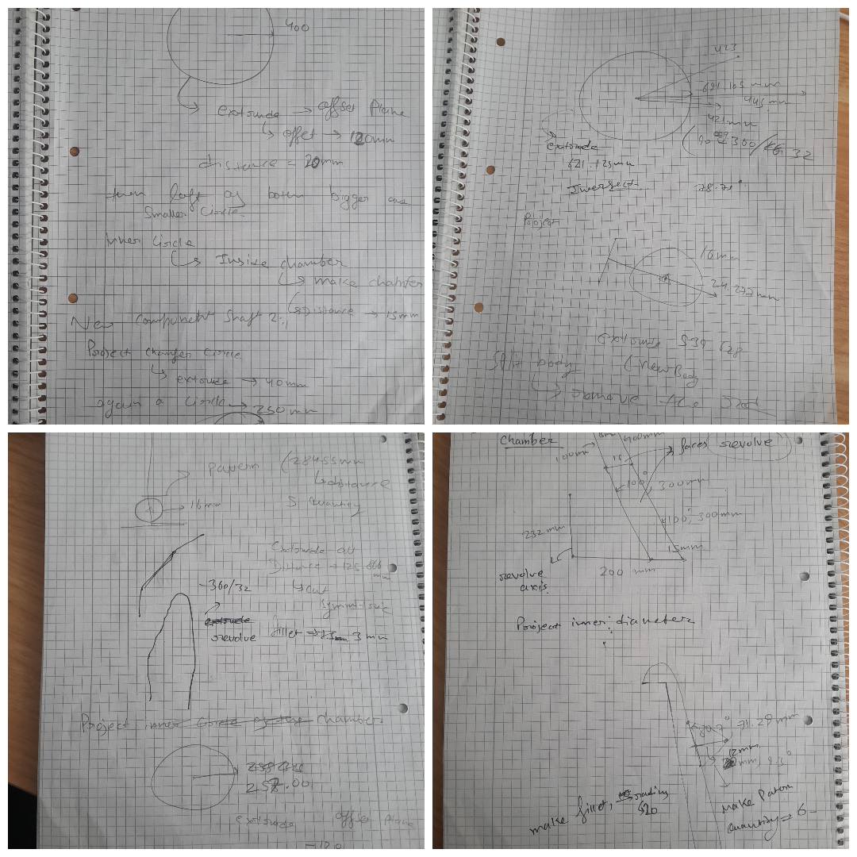
This preliminary design phase simplified the modeling workflow, reduced geometric inconsistencies, and ensured dimensional continuity between the compressor, combustor, and turbine assemblies.

[Figure 11.2: Preliminary engineering sketches used during the conceptual development of the annular combustion chamber. The sketches define the combustor profile, liner geometry, transition section, offset planes, loft operations, perforation layout, and principal dimensions that guided the CAD modeling process in Autodesk Fusion 360.]

11.5 Engineering Considerations
The combustion chamber configuration was developed according to the following engineering considerations:
- Uniform annular combustion volume to promote conceptual fuel-air mixing and stable combustion
- Concentric alignment with the compressor and turbine centerline.
- Smooth geometric transition from the compressor outlet to the turbine inlet.
- Simplified modular construction for ease of CAD development.
- Structural compatibility with adjacent engine components.
- Perforated combustion liner representing primary and dilution air admission.
- Geometry suitable for future thermodynamic and combustion analysis.

11.6 CAD Development Process
The combustion chamber assembly was modeled using Autodesk Fusion 360 through a structured parametric workflow consisting of the following engineering steps:
- Creation of the central engine axis and reference geometry.
- Development of the outer combustion casing.
- Generation of the inner combustion liner using concentric cylindrical geometry.
- Creation of the annular combustion volume between the inner and outer liners.
- Development of the perforation pattern using circular pattern features.
- Modeling of the turbine transition section.
- Application of fillets and geometric refinements.
- Final concentric assembly and integration with the compressor and turbine sections.
This structured workflow ensured dimensional consistency, modular construction, and realistic representation of a modern annular combustion chamber while simplifying future modifications and integration within the complete engine assembly.
The completed combustion chamber provides a modular interface between the high-pressure compressor and turbine assembly while serving as the primary combustion volume for the conceptual turbofan engine.

12 High-Pressure Turbine Design

12.1 Introduction
Explain:
- Purpose of the turbine
- Receives hot combustion gases
- Converts thermal energy into shaft work
- Drives the high-pressure compressor

12.2 Design Objectives
- Represent a conceptual axial turbine.
- Extract energy from combustion gases.
- Maintain concentric shaft alignment.
- Create modular CAD geometry.
- Demonstrate rotor–stator interaction.
- Prepare for thermodynamic analysis.

12.3 Turbine Configuration
Explain:
- Rotor stages
- Stator stages
- Shaft connection
- Gas flow
- Modular assembly
Include one of your overall CAD renders here.
Rotor/Stator explanation
The turbine assembly consists of alternating rotor and stator stages mounted concentrically along the high-pressure shaft. Rotor stages convert the thermal energy of the combustion gases into mechanical work, while stator stages redirect the airflow to maintain an appropriate flow angle for the following rotor stage. The modular arrangement provides a simplified representation of a contemporary multi-stage axial turbine suitable for engineering documentation and conceptual analysis.

12.4 Preliminary Engineering Sketches
Use the notebook pages.
Explain:
- Offset planes
- Loft profiles
- Blade generation
- Shaft
- Pattern operations
- Stage spacing
12.5 Engineering Considerations
Include points like:
- Energy extraction
- Rotor–stator interaction
- Thermal loading
- Concentric alignment
- Stage arrangement
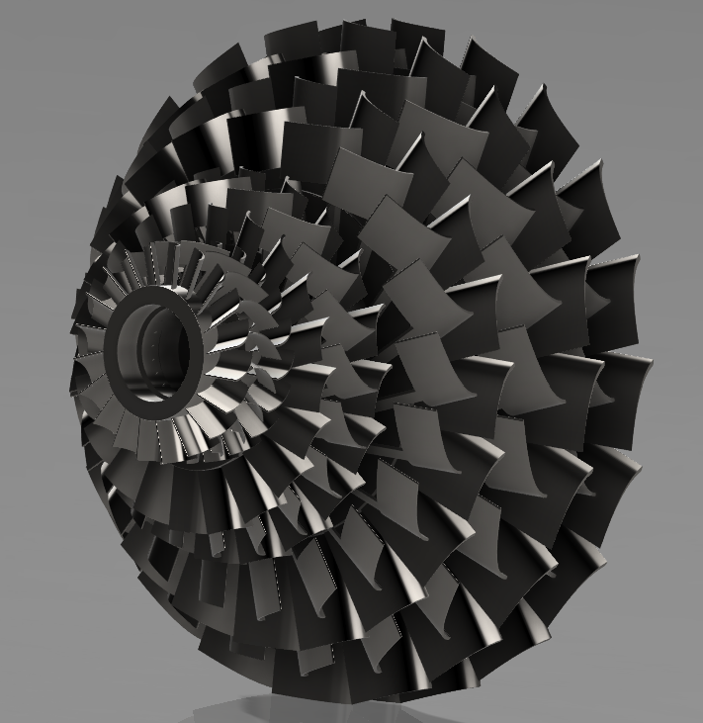
- Modular CAD construction

[Figure 12.1: Isometric CAD rendering of the conceptual multi-stage high-pressure turbine illustrating the complete rotor–stator arrangement, progressive stage configuration, and concentric shaft integration.]

12.6 CAD Development Process
Describe the Fusion 360 workflow:
- Create shaft.
- Develop rotor hub.
- Create blade profile.
- Loft blade.
- Circular pattern.
- Create stator.
- Repeat for stages.
- Assemble.
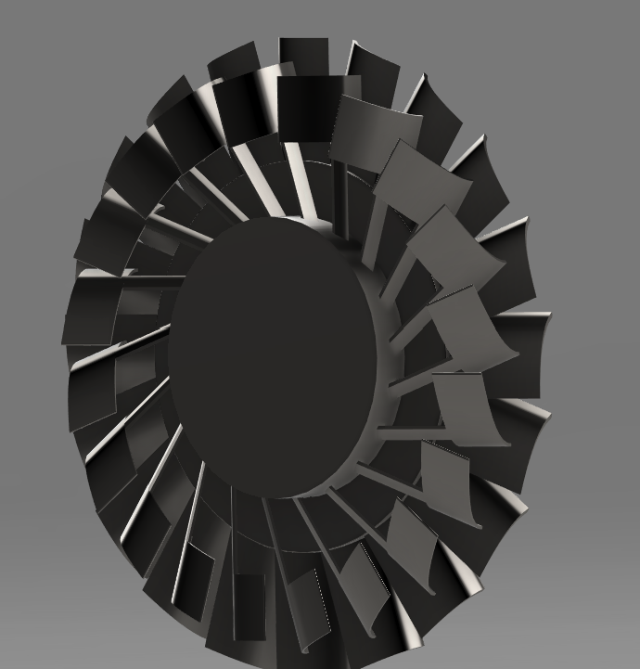
- Apply fillets and refinements.

[Figure 12.2: Front-view CAD rendering of the conceptual high-pressure turbine illustrating the circumferential blade arrangement and concentric rotor geometry.]
12.7 Summary
The completed turbine assembly successfully demonstrates the conceptual architecture of a multi-stage axial turbine through alternating rotor and stator stages. Although simplified for engineering documentation, the assembly accurately represents the structural arrangement required to extract energy from combustion gases and transfer mechanical power to the compressor through the high-pressure shaft. The modular configuration provides a suitable foundation for future thermodynamic analysis, rotor dynamics, and complete engine integration.

13. Low-Pressure Turbine Design

13.1 Introduction
The low-pressure turbine (LPT) is positioned downstream of the high-pressure turbine and extracts the remaining energy from the combustion gases after they have passed through the high-pressure turbine stages. Its primary function is to convert the residual thermal energy into mechanical shaft power required to drive the front fan and low-pressure compressor through the low-pressure shaft.
Modern turbofan engines typically employ several low-pressure turbine stages because the fan requires a significantly higher torque than the high-pressure compressor. Consequently, the low-pressure turbine generally has larger rotor diameters and longer blades than the high-pressure turbine while operating at lower rotational speeds.
The low-pressure turbine developed for this conceptual turbofan project follows the conventional axial-flow architecture employed in modern aircraft engines. Although simplified for engineering documentation, the assembly accurately represents the structural relationship between the combustion chamber, high-pressure turbine, and exhaust system while providing a suitable foundation for future thermodynamic analysis.

13.2 Design Objectives
The low-pressure turbine assembly was developed to satisfy the following engineering objectives:
- Represent the architecture of a modern axial-flow low-pressure turbine.
- Extract remaining thermal energy from combustion gases.
- Drive the front fan through the low-pressure shaft.
- Maintain concentric alignment throughout the engine.
- Demonstrate multi-stage rotor–stator interaction.
- Provide modular CAD geometry suitable for future refinement.
- Prepare the assembly for thermodynamic and performance analysis.

13.3 Turbine Configuration
The conceptual low-pressure turbine consists of alternating rotor and stator stages concentrically arranged along the low-pressure shaft. Compared with the high-pressure turbine, the rotor stages employ progressively larger blade geometry to represent the increased torque required for fan operation.
Each rotor stage converts the remaining thermal energy of the combustion gases into mechanical shaft power, while the stationary stator vanes redirect the airflow to achieve an appropriate inlet angle for the following rotor stage.
The modular stage-by-stage construction method simplified the CAD development process while preserving the characteristic architecture of a contemporary multi-stage low-pressure turbine.The completed low-pressure turbine assembly provides a smooth structural and aerodynamic transition between the high-pressure turbine and the exhaust nozzle while maintaining concentric alignment throughout the engine. The modular stage arrangement also provides a suitable foundation for future thermodynamic performance analysis and complete engine integration.
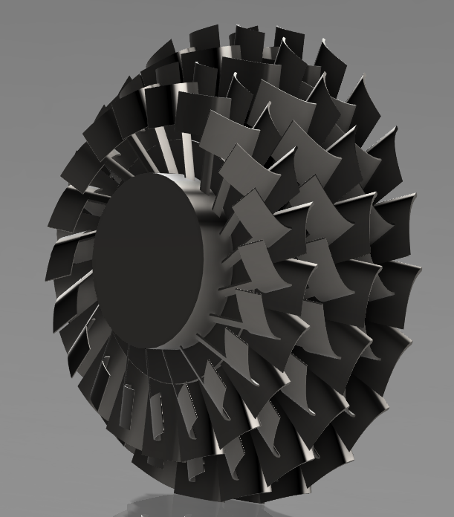

[Figure 13.1: Isometric CAD rendering of the conceptual multi-stage low-pressure turbine illustrating the progressive increase in rotor stage diameter, alternating rotor–stator arrangement, and concentric low-pressure shaft configuration.]

14. Exhaust Nozzle and Flow-Exit Design

14.1 Introduction
The exhaust system forms the downstream flow-exit region of the conceptual turbofan engine. After passing through the turbine stages, the core exhaust gases are directed around the central exhaust plug and discharged through the core exit. The bypass airflow travels through the annular duct between the engine core casing and the outer nacelle before leaving through the bypass exit.
For this project, the exhaust geometry was developed directly from the existing core casing, bypass duct, and nacelle surfaces rather than from a separate analytical sizing process. The objective was to create a mechanically continuous and visually representative rear-engine configuration suitable for conceptual CAD documentation and later thermodynamic analysis.
The resulting arrangement represents a simplified separate-flow turbofan exhaust system. It is not intended to reproduce the precisely optimized nozzle geometry of a production aircraft engine.

14.2 Design Objectives
The exhaust arrangement was developed to satisfy the following conceptual objectives:
- Provide separate exit paths for the core and bypass streams.
- Maintain concentric alignment with the engine centreline.
- Continue the geometry of the core and bypass casings smoothly.
- Incorporate a central exhaust plug downstream of the turbine assembly.
- Preserve compatibility with the completed nacelle and engine assembly.
- Produce a clear geometry for sectional views and technical renderings.
- Establish an initial flow-exit model for later Octave-based performance calculations.

14.3 Exhaust Configuration
The exhaust arrangement consists of two principal flow regions:
Core exhaust path: Hot gases leaving the low-pressure turbine travel through an annular passage surrounding the central exhaust plug. The plug provides an inner flow boundary and gives the core exit a more continuous aerodynamic form.
Bypass exhaust path: Air accelerated by the fan travels through the bypass duct formed between the core casing and outer nacelle. It is discharged through the annular rear region surrounding the core exhaust system.
The geometry was produced by extending and refining the existing casing surfaces instead of defining the exit areas from mass-flow, pressure-ratio, or Mach-number requirements. Therefore, the current model demonstrates structural arrangement and flow-path continuity, while detailed aerodynamic sizing remains part of future work.
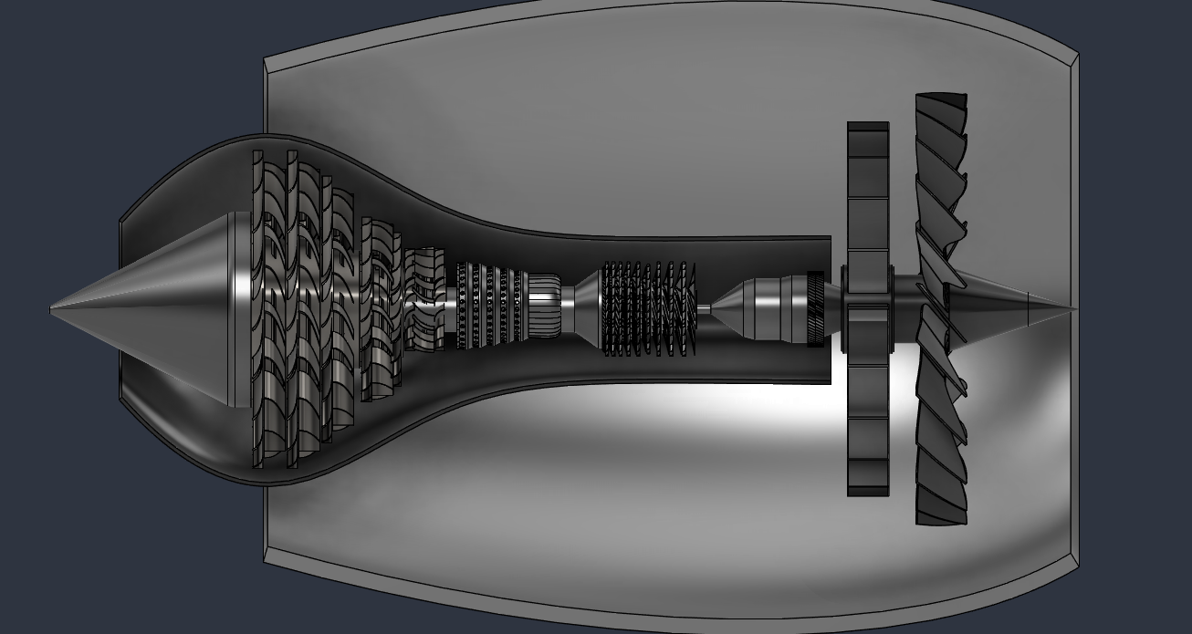

[Figure 14.1: Sectional CAD view of the conceptual turbofan engine illustrating the core exhaust passage, central exhaust plug, surrounding bypass duct, and their integration with the turbine and nacelle assemblies.]

14.4 CAD-Derived Design Approach
No independent preliminary sketch or analytical nozzle-sizing calculation was completed before modelling this component. Instead, the exhaust geometry evolved directly from the completed engine assembly.
The development approach consisted of:
- Extending the downstream core casing from the turbine region.
- Forming the annular core exhaust passage around the engine centreline.
- Creating a central exhaust plug behind the turbine assembly.
- Using the outer nacelle and bypass casing to establish the bypass outlet geometry.
- Adjusting the surface profiles to produce smooth visual transitions.
- Checking concentric alignment and interference with neighbouring components.
- Refining the geometry using fillets and surface transitions.
- Inspecting the completed arrangement using sectional and external views.
This approach was appropriate for the conceptual scope of the project, although it did not establish an aerodynamically optimized nozzle area or expansion ratio.

14.5 Engineering Considerations
The following considerations guided the final geometry:
- Concentric alignment of the core exit, plug, and nacelle.
- Separate representation of core and bypass flow paths.
- Smooth transitions between turbine, core casing, and exhaust region.
- Adequate clearance around the central exhaust plug.
- Structural and visual compatibility with the completed engine assembly.
- Simplified geometry suitable for CAD documentation.
- Availability of measurable inlet and exit areas for later analysis.

14.6 Design Limitations
The present exhaust system was developed without prior analytical sizing; therefore, the following limitations apply
The present exhaust system has the following limitations:
- Core and bypass exit areas were not determined from target mass flow.
- No nozzle pressure-ratio calculation was used during geometric development.
- Choked-flow conditions were not evaluated.
- Exit Mach number and exhaust velocity were not calculated during CAD design.
- Pressure losses through the exhaust system were not modelled.
- Boundary-layer effects and flow separation were not studied.
- No computational fluid dynamics analysis was performed.
- The geometry has not been experimentally validated.
- The central plug and casing profiles were selected conceptually rather than through aerodynamic optimization.
These limitations do not invalidate the model; they clearly define it as a conceptual CAD configuration.

14.7 Future Analytical Sizing
Later, during the Octave phase, we can measure the model’s core and bypass exit diameters and calculate:
- Core exit area.
- Bypass exit area.
- Nozzle pressure ratio.
- Choking condition.
- Exit static temperature and pressure.
- Core and bypass exhaust velocities.
- Momentum thrust.
- Pressure thrust.
- Sensitivity of thrust to exit area.
The subsequent analysis may indicate that the exit geometry requires resizing or refinement. Any resulting modification will be documented as a future design iteration.
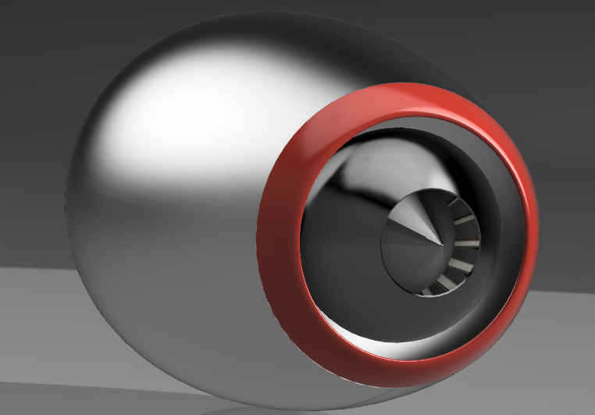

Figure 14.2: External CAD rendering of the completed conceptual turbofan nacelle and exhaust region showing the annular bypass outlet, core exhaust plug, and final aerodynamic surface treatment.]

14.8 Summary
The completed exhaust arrangement provides separate conceptual exit paths for the core and bypass streams while maintaining integration with the turbine, core casing, and outer nacelle. The geometry was developed directly within the complete CAD assembly and was shaped primarily to achieve structural continuity, concentric alignment, and clear representation of the turbofan flow architecture.
Because no independent aerodynamic sizing or preliminary calculation was performed, the current configuration should be considered an initial conceptual model. Its dimensions will serve as inputs for subsequent Octave-based nozzle and thrust analysis, after which the exit geometry may be refined in a future design iteration.

15. Shaft and Spool Arrangement

15.1 Introduction
The shaft and spool system provides the mechanical connection between the turbine stages and the corresponding compression components of the turbofan engine. In a two-spool configuration, the engine contains two independently rotating shaft systems: a low-pressure spool and a high-pressure spool.
The high-pressure spool connects the high-pressure turbine to the multi-stage axial compressor, while the low-pressure spool connects the low-pressure turbine to the fan and low-pressure compression system. This arrangement allows the two rotating systems to operate at different rotational speeds, improving compatibility between the fan, compressor, and turbine assemblies.
The shaft system developed for this conceptual turbofan engine was designed primarily to maintain concentric alignment and demonstrate the mechanical relationship between the major rotating components. Detailed bearing design, rotor-dynamic analysis, lubrication systems, and structural stress calculations were outside the scope of the present phase.

15.2 Design Objectives
The shaft and spool arrangement was developed to:
- Represent a conceptual two-spool turbofan architecture.
- Connect the high-pressure turbine to the compressor.
- Connect the low-pressure turbine to the fan.
- Maintain concentric alignment along the engine centreline.
- Allow independent conceptual rotation of the HP and LP systems.
- Provide mechanical continuity between major rotating assemblies.
- Support later thermodynamic and shaft-power calculations.
- Remain modular for future bearing and rotor-dynamic development.

15.3 Spool Configuration
The conceptual engine contains two principal rotating systems.
High-pressure spool:
The HP spool connects the multi-stage axial compressor to the high-pressure turbine. Energy extracted by the high-pressure turbine is transmitted through the HP shaft to drive the compressor.
Low-pressure spool:
The LP spool connects the low-pressure turbine to the front fan assembly. The larger turbine stages provide the torque required to drive the fan through the concentric LP shaft.
The two shafts are arranged concentrically along the engine centreline. This configuration allows the two spool systems to rotate independently while sharing a common axis.

15.4 Mechanical Arrangement
The shaft arrangement was designed around the following principles:
- Common engine centreline
- Concentric shaft placement
- Separation of HP and LP rotating systems
- Axial continuity between turbine and compressor sections
- Modular assembly of individual rotating components
- Simplified geometry for CAD representation
- Sufficient clearance between concentric parts

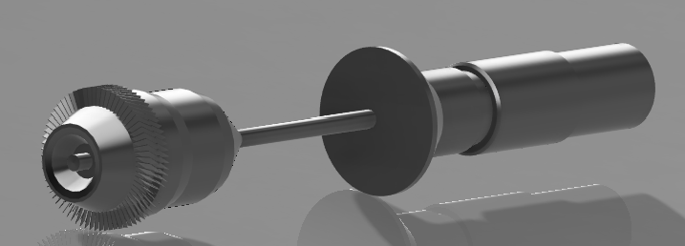
[Figure 15.1: Isometric CAD rendering of the conceptual two-spool turbofan engine illustrating the concentric low-pressure and high-pressure shaft arrangement and the mechanical connection between the fan, compressor, and turbine assemblies.]

16. Complete Engine Assembly
16.1 Introduction
- Explain that all major engine components have now been integrated into a complete conceptual turbofan assembly.
16.2 Assembly Overview
- Fan
- Low-pressure compressor
- High-pressure compressor
- Combustion chamber
- High-pressure turbine
- Low-pressure turbine
- Shaft system
- Exhaust nozzle
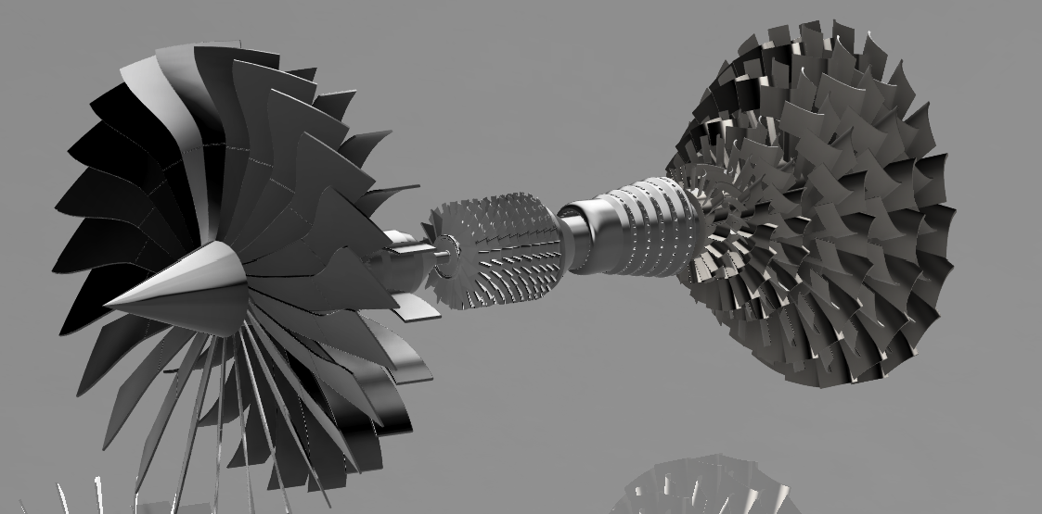
- Nacelle

[Figure 16.1: Exploded CAD rendering of the complete conceptual turbofan engine assembly illustrating the modular arrangement of the fan, compressor, combustion chamber, turbine stages, shaft system, and overall engine integration.]

16.3 CAD Assembly Process
- Component creation
- Concentric alignment
- Assembly constraints
- Final integration
- Rendering
16.4 Sectional Views
- Longitudinal section
- Core flow path
- Bypass flow path
- Component locations
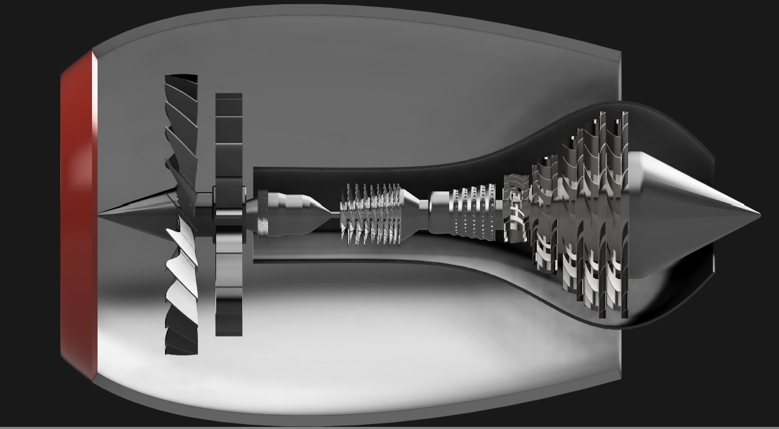

[Figure 16.2: Longitudinal sectional CAD view of the completed conceptual turbofan engine illustrating the internal arrangement of the fan, compressor, combustion chamber, turbine stages, shaft system, bypass duct, and exhaust region.]

16.5 Engineering Considerations
• Concentric alignment of all rotating assemblies.
• Modular architecture to simplify future modifications.
• Continuous integration between major engine components.
• Structural compatibility between the nacelle, core, and rotating systems.
• Simplified geometry suitable for conceptual engineering documentation.
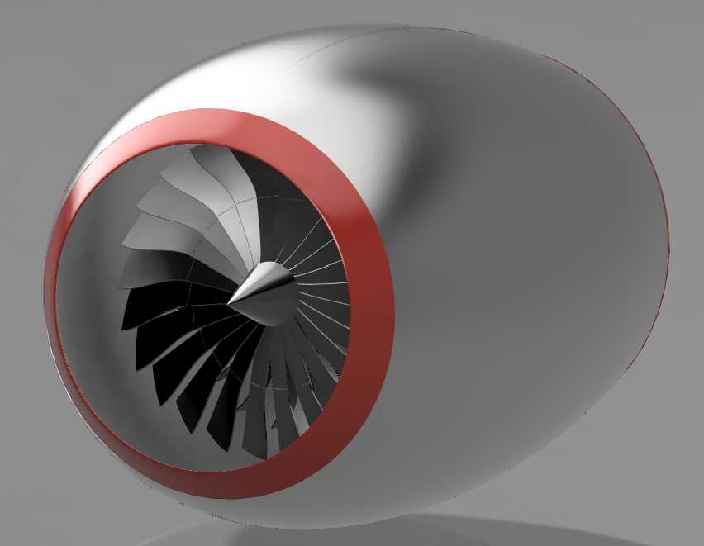

[Figure 16.3: External CAD rendering of the completed conceptual turbofan engine illustrating the nacelle, inlet lip, spinner, and front fan assembly.]

16.6 Design Limitations
- Conceptual CAD model
- No CFD
- No FEA
- No bearing analysis
- No rotor dynamics
- No manufacturing tolerances
- No vibration analysis
- No thermal stress analysis performed.

16.7 Summary
- Explain that the engine assembly is now complete and forms the foundation for the next phase: thermodynamic analysis and performance estimation.
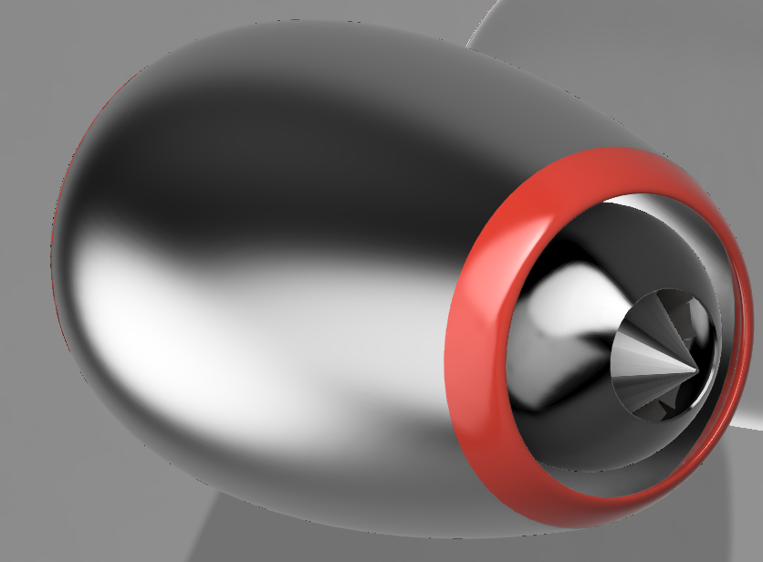

[Figure 16.4: Rear perspective CAD rendering of the completed conceptual turbofan engine showing the exhaust nozzle, central exhaust plug, and final nacelle integration]

17. Thermodynamic Cycle Analysis Using GNU Octave
17.1 Introduction
Following completion of the conceptual CAD model, a thermodynamic cycle analysis was initiated to estimate the theoretical operating characteristics of the two-spool turbofan engine. The CAD model defines the geometric arrangement of the fan, compressor, combustion chamber, turbine stages, concentric shaft system, bypass duct, and exhaust region; however, geometric modelling alone does not determine the pressure, temperature, energy, velocity, or thrust produced by the engine.
GNU Octave was selected as the computational platform because it provides numerical calculation, data-processing, and graph-generation capabilities suitable for conceptual engineering analysis. The model will be developed progressively, with each major engine component represented by a separate set of thermodynamic relationships.
The analysis considers the engine as a conceptual separate-flow, two-spool turbofan. The airflow is divided into core and bypass streams after the fan. The core stream passes through the compressor, combustion chamber, high-pressure turbine, low-pressure turbine, and core exhaust nozzle, while the bypass stream travels through the outer bypass duct and exits through the bypass outlet.
The objective of the analysis is to estimate the variation of total temperature and total pressure through the engine, component-specific work requirements, turbine energy extraction, fuel–air ratio, nozzle exit velocities, thrust, fuel consumption, and theoretical efficiency. The calculated results will subsequently be used to generate engineering tables and graphical representations of the engine cycle.
Because detailed component maps, experimental measurements, and validated aerodynamic data are not available, the analysis uses assumed conceptual performance parameters and simplified one-dimensional gas-turbine relationships. Therefore, the results are intended for educational study, preliminary design evaluation, and portfolio documentation rather than certification or production-engine prediction.
17.2 Scope of Analysis and Assumptions
The thermodynamic model was developed as a preliminary one-dimensional analysis of a conceptual separate-flow, two-spool turbofan engine. The purpose of the model is to estimate the principal thermodynamic changes occurring through the engine and to generate first-order performance results suitable for engineering documentation.

The analysis includes the following processes:
- Calculation of atmospheric and flight conditions.
- Inlet ram compression and pressure recovery.
- Fan pressure and temperature rise.
- Core compressor pressure and temperature rise.
- Heat addition within the combustion chamber.
- High-pressure turbine work extraction.
- Low-pressure turbine work extraction.
- Expansion through the core exhaust nozzle.
- Expansion through the bypass exhaust outlet.
- Core and bypass momentum thrust estimation.
- Fuel–air ratio and fuel-flow calculation.
- Specific thrust and thrust-specific fuel consumption.
- Thermal, propulsive, and overall efficiency estimation.
The first version of the model is based on the following assumptions:
- Steady-state engine operation.
- One-dimensional flow through each engine station.
- Air and combustion gases are treated as ideal gases with constant specific heat values.
- Uniform pressure and temperature at each station.
- Constant specific heats within the air and gas regions.
- No bleed-air extraction from the compressor.
- No turbine-cooling airflow.
- No transient spool acceleration.
- No afterburner or exhaust-stream mixer.
- Separate core and bypass exhaust streams.
- Simplified component efficiencies and pressure losses.
- No installation drag or nacelle drag.
- No detailed compressor or turbine performance maps.
- No heat transfer through the engine casing.
- No mechanical vibration or rotor-dynamic effects.
These assumptions reduce the complexity of the analysis while preserving the principal thermodynamic relationships required to study the conceptual engine cycle. More advanced effects may be incorporated in future versions of the model.

17.3 Engine Station Definition

Introduction
To simplify the thermodynamic analysis, the conceptual turbofan engine is divided into a series of engine stations. Each station represents a location where the thermodynamic properties of the working fluid are evaluated. Total pressure, total temperature, static pressure, static temperature, velocity, and mass flow rate are calculated or estimated at these locations throughout the engine cycle.
The station numbering follows the airflow path from the engine inlet to the exhaust nozzles. The bypass and core streams are analysed separately after the fan while maintaining a common inlet condition.
Engine Stations
Station | Description
0 | Ambient atmosphere
2 | Engine inlet
21 | Fan exit
25 | Core compressor inlet
3 | High-pressure compressor exit
4 | Combustor exit (turbine inlet)
45 | High-pressure turbine exit
5 | Low-pressure turbine exit
8 | Core nozzle exit
13 | Bypass nozzle exit

Flow Sequence

Core Flow
0 → 2 → 21 → 25 → 3 → 4 → 45 → 5 → 8

Bypass Flow
0 → 2 → 21 → 13

Engineering Purpose
The station numbering provides a consistent framework for all thermodynamic calculations performed in GNU Octave. Pressure ratios, temperature changes, work transfer, heat addition, and nozzle expansion are all evaluated between successive engine stations. This approach follows standard gas turbine analysis practices and simplifies both numerical implementation and graphical representation of the engine cycle.
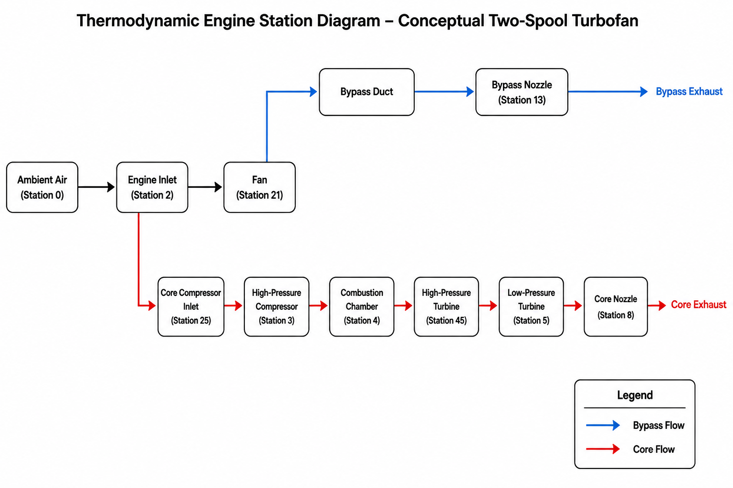

[Figure 17.1: Thermodynamic engine station diagram illustrating the airflow path and engine station numbering used for the conceptual two-spool turbofan thermodynamic analysis in GNU Octave.]

17.4 Input Parameters
The thermodynamic model requires a set of atmospheric, engine, and gas-property parameters that define the operating condition of the conceptual turbofan engine. These parameters remain constant throughout the initial analysis unless otherwise stated. Values are selected from standard aerospace engineering references and simplified assumptions appropriate for conceptual engine-cycle analysis.
Parameter | Symbol | Value | Unit
Ambient temperature | T₀ | 288.15 | K
Ambient pressure | P₀ | 101.325 | kPa
Flight Mach number | M₀ | 0.00 | –
Flight velocity | V₀ | 0 | m/s
Fan pressure ratio | πf | 1.60 | –
Compressor pressure ratio | πc | 12.0 | –
Bypass ratio | BPR | 5.0 | –
Turbine inlet temperature | Tt4 | 1400 | K
Combustor pressure loss | ΔPc | 5 | %
Compressor efficiency | ηc | 0.86 | –
Turbine efficiency | ηt | 0.90 | –
Nozzle efficiency | ηn | 0.95 | –
Mechanical efficiency | ηm | 0.99 | –
Gas constant | R | 287 | J/(kg·K)
Specific heat | Cp | 1005 | J/(kg·K)
Ratio of specific heats | γ | 1.40 | –
Fuel heating value | LHV | 43×10⁶ | J/kg

17.5 Atmospheric and Flight Conditions

17.5.1 Introduction
Before analysing the thermodynamic cycle of the turbofan engine, the ambient operating conditions must be defined. These atmospheric conditions establish the initial state of the airflow entering the engine and serve as the reference point for all subsequent pressure, temperature, velocity, and energy calculations.
For this conceptual analysis, the engine is assumed to operate under standard International Standard Atmosphere (ISA) sea-level conditions with zero flight speed. These assumptions simplify the numerical model while providing a consistent baseline for evaluating engine performance.
The atmospheric properties calculated in this section become the inlet conditions for the engine inlet (Station 2) and are subsequently used throughout the compressor, combustor, turbine, and nozzle analyses.

17.5.2 Engineering Objectives
- Define atmospheric reference conditions.
- Establish inlet temperature and pressure.
- Calculate flight velocity from Mach number.
- Calculate total inlet temperature.
- Calculate total inlet pressure.
- Provide input conditions for the thermodynamic cycle.
- Validate the initial engine station.

17.5.3 Governing Equations
Ambient Temperature
T₀ = 288.15 K
Ambient Pressure
P₀​= 101325 Pa

Speed of Sound
A = √γRT₀​
where
- γ = 1.4
- R = 287 J/kgK

Flight Velocity
V₀ = M₀a

Total Temperature
$${\text{T}}_{\text{t}\text{0}}\text{​=}{\text{T}}_{\text{0}}\text{​(1}\text{+ }\frac{\text{γ} \text{−} \text{1}}{\text{2}} {\text{M}}_{\text{0}}^{\text{2}}\text{​)}$$

Total Pressure

$${\text{P}}_{\text{t0}} \text{=} {\text{P}}_{\text{0}} {\text{(1}\text{ + }\frac{\text{γ} \text{−} \text{1}}{\text{2}} {\text{M}}_{\text{0}}^{\text{2}}\text{ )}}^{\frac{\text{γ}}{ \text{γ} \text{−} \text{1}} } \text{​}$$

17.5.4 Octave Implementation

17.5.5 First Octave Script
T0 = 288.15;
P0 = 101325;
gamma = 1.4;
R = 287;

a = sqrt(gamma*R*T0);
V0 = Mach*a;

Tt0 = T0*(1+((gamma-1)/2)*Mach^2);
Pt0 = P0*(1+((gamma-1)/2)*Mach^2)^(gamma/(gamma-1));

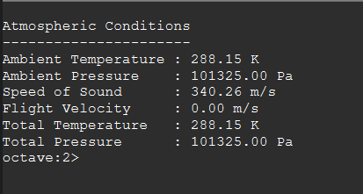
[The complete GNU Octave source code is provided in Appendix A and the project repository.]
17.5.6 Octave Output

17.6 Compressor Analysis
17.6.1 Introduction
The compressor is one of the most important components of a gas turbine engine. Its primary function is to increase the pressure of the incoming air before it enters the combustion chamber. By compressing the air, the compressor enables efficient combustion and increases the amount of energy that can be extracted by the turbine.
In the conceptual two-spool turbofan engine developed for this project, the compression process occurs in two stages. The fan provides the initial pressure increase to both the core and bypass streams, while the high-pressure compressor further compresses only the core airflow before combustion.
For this preliminary thermodynamic model, the compressor is assumed to operate under steady-state conditions with a constant pressure ratio and isentropic efficiency. The calculations estimate the total pressure rise, total temperature rise, and compressor work required for the specified operating conditions.

17.6.2 Engineering Objectives
- Calculate compressor exit pressure.
- Calculate compressor exit temperature.
- Determine compressor work.
- Estimate compressor power requirement.
- Evaluate compressor performance using isentropic relations.
- Provide inlet conditions for the combustor.
17.6.3 Governing Equations
Compressor Pressure Ratio
${\text{π}}_{\text{c}}\text{=}\frac{{\text{P}}_{\text{t3}}}{{\text{P}}_{\text{t25}}}​$
where
- P_{t25}​ = compressor inlet total pressure
- P_{t3} = compressor exit total pressure

Compressor Exit Pressure
$${\text{P}}_{\text{t3}}\text{​=}{\text{P}}_{\text{t25}}\text{×}{ \text{π}}_{\text{c}}\text{​}$$

Ideal Exit Temperature
$${\text{T}}_{\text{t3s}}\text{​=} {\text{T}}_{\text{t25}}\text{​×}{ \text{π}}_{\text{c}}^{\frac{\text{γ−1}}{\text{γ}}}\text{​}​$$

Actual Exit Temperature

$$T_{t3}​= T_{t25}​+ \frac{T_{t3s} − T_{t25}​}{ηc}​$$

Compressor Specific Work

$${\text{W}}_{\text{c}}\text{=} {\text{C}}_{\text{p}} \text{(}{\text{T}}_{\text{t3}}\text{−} {\text{T}}_{\text{t25}}\text{)}$$

Compressor Power

$${\text{P}}_{\text{c}}\text{​=} {\dot{\text{m}}}_{\text{core}} {\text{W}}_{\text{c}}\text{​}$$

17.6.4 Octave Implementation
Pt3 = Pt25*pi_c;

Tt3s = Tt25*pi_c^((gamma-1)/gamma);

Tt3 = Tt25 + (Tt3s-Tt25)/eta_c;

Wc = Cp*(Tt3-Tt25);

Pc = mdot_core*Wc;
[The complete GNU Octave implementation is provided in Appendix A and the accompanying project repository.]

17.6.5 Octave Output
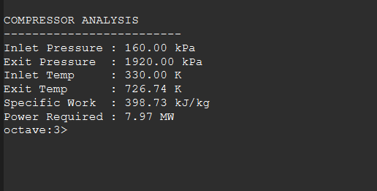

17.6.6 Results and Discussion
The compressor successfully increased the total pressure of the core airflow by the specified pressure ratio while increasing the total temperature due to the work input required for compression. The calculated compressor work represents the energy that must be supplied by the high-pressure turbine later in the engine cycle. The resulting compressor exit conditions form the inlet state for the combustion chamber and are therefore critical to the overall engine performance.

17.7 Combustion Chamber Analysis

17.7.1 Introduction
The combustion chamber is located downstream of the high-pressure compressor and upstream of the high-pressure turbine. Its primary function is to mix the compressed core airflow with fuel and release chemical energy through combustion. This process produces a substantial increase in total temperature while introducing a comparatively small reduction in total pressure.
In the conceptual turbofan cycle, the compressor delivers high-pressure air to the combustion chamber at Station 3. Fuel is then added to the core airflow, increasing the gas temperature to the specified turbine inlet temperature at Station 4. The resulting high-temperature combustion gases provide the energy required to drive the high-pressure and low-pressure turbine stages.
For this preliminary thermodynamic analysis, the combustion process is represented using a steady-flow energy balance. Combustion is assumed to occur with a specified combustion efficiency and pressure loss. Detailed chemical reactions, flame structure, emissions, cooling airflow, and spatial temperature variations are outside the scope of the present model.

17.7.2 Engineering Objectives
The combustion-chamber analysis was developed to:
- Calculate the total pressure at the combustor exit.
- Establish the specified turbine inlet temperature.
- Determine the required fuel–air ratio.
- Calculate the fuel mass-flow rate.
- Calculate the total gas mass flow entering the turbine.
- Estimate the thermal energy supplied by the fuel.
- Provide Station 4 conditions for the turbine analysis.

17.7.3 Input Conditions
Parameter | Symbol | Value | Unit
Combustor inlet temperature | T_{t3}​ | 726.74 | K
Combustor inlet pressure | P_{t3}​ | 1920 | kPa
Turbine inlet temperature | T_{t4}​ | 1400 | K
Combustor pressure loss | ΔP_{b}​ | 5 | %
Combustion efficiency | η_{b}​ | 0.99 | –
Core mass flow | $\dot{\text{m}}$_{C} | 20 | kg/s
Specific heat capacity | C_{p}​ | 1005 | J/(kg·K)
Fuel lower heating value | LHV | 43 × 10⁶ | J/kg
Combustion efficiency | η_{b}​ | 0.99 | –

17.7.4 Governing Equations

Combustor Exit Pressure
A 5% total-pressure loss is assumed:
$${\text{P}}_{\text{t4}}\text{​=}{\text{P}}_{\text{t3}}\text{​(1−}{\text{ΔP}}_{\text{b}}\text{​)}$$
where the percentage must be converted into decimal form:
$${\text{ΔP}}_{\text{b}}\text{​=} \frac{\text{5}}{\text{100}} \text{=0.05}$$
Therefore:
$${\text{P}}_{\text{t4}}\text{=}{\text{P}}_{\text{t3}} \text{(1} \text{−} \text{0.05)}$$

Combustor Energy Balance

The simplified steady-flow energy balance is:

$${\text{C}}_{\text{p}}{\text{T}}_{\text{t3}} \text{+} {\text{fη}}_{\text{b}}\text{LHV} \text{=(1+f)}{\text{C}}_{\text{p}}{\text{T}}_{\text{t4}}\text{​}$$

where f is the fuel–air ratio.
Rearranging gives:
$$\text{f} \text{=} \frac{{\text{C}}_{\text{p}} \text{(}{ \text{T}}_{\text{t4}} \text{−}{ \text{T}}_{\text{t3}} \text{)}}{{\text{η}}_{\text{b}}\text{LHV} \text{−} {\text{C}}_{\text{p}}{\text{T}}_{\text{t4}}}\text{​}$$
This form accounts for the additional fuel mass leaving the combustor.
Fuel Mass-Flow Rate
$$\dot{\text{m}}\text{f} \text{=} {\text{f}\dot{\text{m}}}_{\text{c}}\text{​}$$

Turbine Gas Mass Flow
The gas entering the turbine contains both air and fuel:
$${\dot{\text{m}}}_{\text{g}} \text{=}{\dot{\text{m}}}_{\text{c}} \text{+} {\dot{\text{m}}}_{\text{f}}\text{​}$$
or:
$${\dot{\text{m}}}_{\text{g}} \text{=}{\dot{ \text{m}}}_{\text{c}}\text{(} \text{1} \text{+} \text{f} \text{)}$$
Fuel Thermal Power
$${\dot{\text{Q}}}_{\text{fuel}} \text{=} {\dot{\text{m}}}_{\text{f}}\text{LHV}$$

This is the chemical-energy rate supplied by the fuel.

17.7.5 Octave Implementation
clear;
clc;
close all;

%% 17.7 Combustion Chamber Analysis

% Compressor exit conditions from Section 17.6
Tt3 = 726.74; % Combustor inlet total temperature, K
Pt3 = 1920e3; % Combustor inlet total pressure, Pa

% Combustor assumptions
Tt4 = 1400; % Turbine inlet temperature, K
pressure_loss = 0.05; % Combustor total-pressure loss
eta_b = 0.99; % Combustion efficiency
LHV = 43e6; % Fuel lower heating value, J/kg
Cp = 1005; % Specific heat capacity, J/(kg K)

% Core airflow
mdot_core = 20; % kg/s

%% Combustor exit pressure

Pt4 = Pt3 * (1 - pressure_loss);

%% Fuel-air ratio

numerator = Cp * (Tt4 - Tt3);
denominator = eta_b * LHV - Cp * Tt4;

f = numerator / denominator;

%% Fuel and turbine-gas mass flow

mdot_fuel = f * mdot_core;
mdot_gas = mdot_core + mdot_fuel;

%% Fuel thermal power

fuel_power = mdot_fuel * LHV;

%% Display results

fprintf("\n");
fprintf("COMBUSTION CHAMBER ANALYSIS\n");
fprintf("---------------------------\n");
fprintf("Inlet total temperature : %.2f K\n", Tt3);
fprintf("Exit total temperature : %.2f K\n", Tt4);
fprintf("Inlet total pressure : %.2f kPa\n", Pt3 / 1000);
fprintf("Exit total pressure : %.2f kPa\n", Pt4 / 1000);
fprintf("Combustor pressure loss : %.2f %%\n", pressure_loss * 100);
fprintf("Fuel-air ratio : %.5f\n", f);
fprintf("Core air mass flow : %.3f kg/s\n", mdot_core);
fprintf("Fuel mass flow : %.3f kg/s\n", mdot_fuel);
fprintf("Turbine gas mass flow : %.3f kg/s\n", mdot_gas);
fprintf("Fuel thermal power : %.3f MW\n", fuel_power / 1e6);

17.7.6 Octave Output
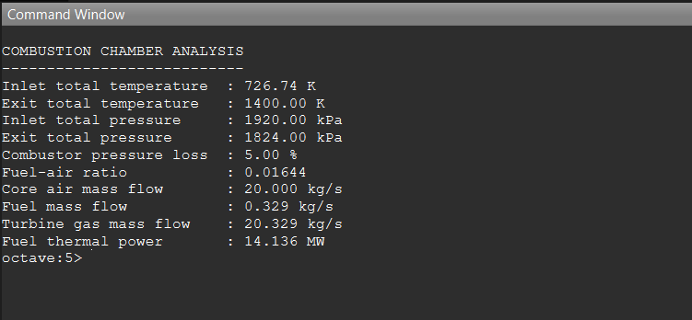

The calculated fuel-air ratio of approximately 0.016 lies within the expected operating range for modern turbofan engines operating at high turbine inlet temperatures. The combustor pressure loss of 5% remains consistent with simplified gas-turbine cycle assumptions used in preliminary engine performance analysis. The calculated turbine gas mass flow is slightly greater than the compressor inlet air mass flow because of the addition of fuel during combustion.

The combustion analysis assumes complete combustion, constant specific heats, steady one-dimensional flow, negligible kinetic energy change across the combustor, and uniform exit temperature distribution.

17.8 High-Pressure Turbine Analysis

17.8.1 Introduction
The high-pressure turbine (HPT) is located immediately downstream of the combustion chamber and is the first turbine stage encountered by the high-temperature combustion gases. Its primary function is to extract sufficient energy from the expanding gases to drive the high-pressure compressor through the high-pressure shaft.
Within the conceptual two-spool turbofan engine, the turbine receives combustion gases at Station 4 and expands them to Station 45. During this expansion process, the gas performs mechanical work on the turbine blades, causing a reduction in both total temperature and total pressure. The extracted work is transmitted through the concentric high-pressure shaft to power the compressor.
For this preliminary thermodynamic model, the turbine is represented using a steady-flow one-dimensional analysis with constant specific heats and a specified turbine efficiency. Cooling airflow, blade heat transfer, secondary losses, and detailed turbine aerodynamics are neglected in order to maintain a simplified conceptual cycle model suitable for engineering evaluation and educational purposes.

17.8.2 Engineering Objectives
The high-pressure turbine analysis was developed to:
- Calculate the turbine exit total temperature.
- Calculate the turbine exit total pressure.
- Determine the turbine specific work output.
- Verify that turbine work matches compressor power requirements.
- Estimate turbine power production.
- Establish Station 45 conditions for the low-pressure turbine analysis.
- Provide thermodynamic data for the remainder of the engine cycle.

17.8.3 Input Conditions
Parameter | Symbol | Value | Unit
Turbine inlet temperature | Tt₄ | 1400 | K
Turbine inlet pressure | P_{t₄} | 1824 | kPa
Compressor specific work | W_{c} | 398.73 | kJ/kg
Turbine efficiency | η_{t} | 0.90 | —
Specific heat | C_{p} | 1005 | J/(kg·K)
Ratio of specific heats | γ | 1.40 | —
Core mass flow | ṁ_{core} | 20 | kg/s

17.8.4 Governing Equations

Turbine Work Balance
The turbine is assumed to provide the power required by the high-pressure compressor.
Therefore, the turbine specific work is assumed to be equal to the compressor specific work, neglecting mechanical transmission losses during this preliminary analysis.
W_{t}​= W_{c}​
Turbine Exit Temperature

$${\text{T}}_{\text{t45} }\text{​=}{\text{T}}_{\text{t4}}\text{​−} \frac{{\text{W}}_{\text{t}}}{{\text{C}}_{\text{p}}}\text{​​}$$

Ideal Exit Temperature

$${\text{T}}_{\text{t45s}}\text{​=}{\text{T}}_{\text{t4}}\text{​−}{\text{η}}_{\text{t} }\text{​(}{\text{T}}_{\text{t4}}\text{​−}{\text{T}}_{\text{t45}}\text{​)}$$

Turbine Pressure Ratio
The turbine pressure ratio is obtained from the isentropic temperature relation using the ideal exit temperature.

$${\text{P}}_{\text{t45}}\text{=} {\text{P}}_{\text{t4}} {\text{(} \frac{{\text{T}}_{\text{t45s}}}{{\text{T}}_{\text{t4}}} \text{)}}^{\frac{\text{γ}}{\text{γ−1}}} \text{​}$$

Turbine Power
$${\text{P}}_{\text{t}} \text{=} {\dot{\text{m}}}_{\text{core}} {\text{W}}_{\text{t}}​$$
17.8.5 Octave Implementation
The following GNU Octave script calculates the high-pressure turbine exit conditions using the governing equations presented in the previous section. The script determines the turbine exit pressure, exit temperature, turbine work, and power required to drive the high-pressure compressor.

17.8.6 First Octave Script
clear;
clc;
close all;

%% HIGH-PRESSURE TURBINE ANALYSIS

%% Inputs
Tt4 = 1400; % K
Pt4 = 1824e3; % Pa

Cp = 1005; % J/kg-K
gamma = 1.4;

eta_t = 0.90;

mdot_core = 20; % kg/s

%% Compressor work from Chapter 17.6
Wc = 398.73e3; % J/kg

%% Turbine work
Wt = Wc;

%% Actual turbine exit temperature
Tt45 = Tt4 - Wt/Cp;

%% Ideal exit temperature
Tt45s = Tt4 - eta_t*(Tt4 - Tt45);

%% Turbine exit pressure
Pt45 = Pt4*(Tt45s/Tt4)^(gamma/(gamma-1));

%% Turbine Power
Pturbine = mdot_core*Wt;

%% Results

fprintf('\n');
fprintf('HIGH-PRESSURE TURBINE ANALYSIS\n');
fprintf('------------------------------------\n');

fprintf('Inlet Temperature : %.2f K\n',Tt4);
fprintf('Exit Temperature : %.2f K\n',Tt45);

fprintf('Inlet Pressure : %.2f kPa\n',Pt4/1000);
fprintf('Exit Pressure : %.2f kPa\n',Pt45/1000);

fprintf('Specific Work : %.2f kJ/kg\n',Wt/1000);

fprintf('Turbine Power : %.2f MW\n',Pturbine/1e6);

17.8.7 Octave Output
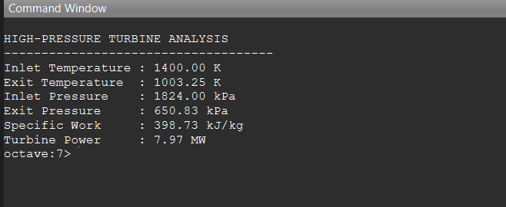

The numerical results presented above were obtained directly from the GNU Octave implementation using the governing equations and input parameters defined in this chapter. These values establish the inlet conditions for the subsequent low-pressure turbine analysis.
17.8.8 Results and Discussion
The high-pressure turbine successfully extracted sufficient energy from the combustion gases to supply the work required by the high-pressure compressor. As expected, both the total temperature and total pressure decreased during the expansion process while mechanical power was transferred to the compressor through the high-pressure shaft. The calculated exit conditions at Station 45 establish the inlet conditions for the low-pressure turbine analysis presented in the following section. The simplified model assumes steady one-dimensional flow, constant specific heats, and neglects turbine cooling air, secondary losses, and detailed blade aerodynamics.
The decrease in total pressure results from the thermodynamic expansion through the turbine and the assumed turbine efficiency, which accounts for irreversible losses during energy extraction.

17.9 Low-Pressure Turbine Analysis

17.9.1 Introduction
The low-pressure turbine (LPT) is positioned immediately downstream of the high-pressure turbine and represents the final turbine stage within the core engine. Its primary function is to extract the remaining energy from the combustion gases to drive the fan and low-pressure compressor through the low-pressure shaft.
Following expansion through the high-pressure turbine, the combustion gases enter the low-pressure turbine at Station 45. As the gases continue to expand, additional thermal energy is converted into mechanical work, resulting in a further reduction in total temperature and total pressure before the gases enter the core exhaust nozzle.
Within the conceptual two-spool turbofan engine developed for this project, the low-pressure turbine is assumed to supply the work required by the fan and low-pressure compressor while maintaining steady one-dimensional flow. Similar to the previous analyses, turbine cooling airflow, secondary flow effects, blade heat transfer, and detailed aerodynamic losses are neglected to maintain a simplified conceptual thermodynamic model suitable for engineering evaluation and educational purposes.

17.9.2 Engineering Objectives
The low-pressure turbine analysis was developed to:
- Calculate the turbine exit total temperature.
- Calculate the turbine exit total pressure.
- Determine the low-pressure turbine specific work output.
- Verify that the extracted turbine work is sufficient to drive the fan and low-pressure compressor.
- Estimate the mechanical power delivered to the low-pressure shaft.
- Establish Station 5 conditions for the core exhaust nozzle analysis.
- Provide thermodynamic data for the final expansion stage of the engine cycle.

17.9.3 Input Conditions
Parameter | Symbol | Value | Unit
LPT inlet temperature | T_{t45}​ | 1003.25 | K
LPT inlet pressure | P_{t45} | 650.83 | kPa
Turbine gas mass flow | $${\dot{\text{m}}}_{\text{g}}$$ | 20.329 | kg/s
Bypass ratio | BPR | 5.0 | –
Fan total mass flow | $${\dot{\text{m}}}_{\text{fan}}$$ | 120.000 | kg/s
Fan specific work | W_{fan} | 50 | kJ/kg
Low-pressure compressor work | W_{LPC} | 70 | kJ/kg
Mechanical efficiency | ηm | 0.99 | –
Turbine efficiency | ηt | 0.90 | —
Specific heat | Cp | 1005 | J/(kg·K)
Ratio of specific heats | γ | 1.40 | —
Core mass flow | $${\dot{\text{m}}}_{\text{core}}$$ | 20 | kg/s
Bypass mass flow | $\dot{\text{m}}$_{bypass} | 100.000 | kg/s

For this preliminary analysis, the fan and low-pressure compressor specific works are assumed values. Their individual power requirements are calculated using their respective mass-flow rates, and the low-pressure turbine is sized thermodynamically to supply the resulting combined LP-shaft power.

17.9.4 Governing Equations

Fan mass flow
$${\dot{\text{m}}}_{\text{fan}} \text{=}{\dot{\text{m}}}_{\text{core}}\text{(} \text{1} \text{+} \text{BPR} \text{)}$$
Fan power

$${\text{P}}_{\text{fan}} \text{=} {\dot{\text{m}}}_{\text{fan}}{\text{W}}_{\text{fan}}\text{​}$$

LPC power

$${\text{P}}_{\text{LPC}} \text{=} {\dot{\text{m}}}_{\text{core}} {\text{W}}_{\text{LPC}}​$$

Required turbine power

$${\text{P}}_{\text{LPT}}\text{​=}\frac{{\text{P}}_{\text{fan}}\text{​+} {\text{P}}_{\text{LPC}}}{\text{ηm​}}\text{​}​$$
Turbine Exit Temperature

$${\text{T}}_{\text{t5}} \text{=} {\text{T}}_{\text{t45}} \text{−} \frac{{\text{W}}_{\text{LPT}}}{{\text{C}}_{\text{p}}}\text{​}​$$

Low-Pressure Turbine Specific Work

$${\text{W}}_{\text{LPT}} \text{=} \frac{{\text{P}}_{\text{LPT}}}{{\dot{\text{m}}}_{\text{g}}}\text{​}​$$

Ideal Exit Temperature

$${\text{T}}_{\text{t5s}} \text{=}{\text{T}}_{\text{t45}} \text{−ηt} \text{(}{\text{T}}_{\text{t45}} \text{−} {\text{T}}_{\text{t5}} \text{)}$$

Turbine Exit Pressure

The turbine pressure ratio is obtained using the isentropic temperature relationship.

$${\text{P}}_{\text{t5}} \text{=} {\text{P}}_{\text{t45}} {\text{(} \frac{{\text{T}}_{\text{t5s}}}{{\text{T}}_{\text{t45}}} \text{)}}^{\frac{\text{γ}}{\text{γ−1}}}\text{​}$$

Low-Pressure Compressor Power
$${\text{P}}_{\text{LP}\text{C}} \text{=} {\dot{\text{m}}}_{\text{core}} {\text{W}}_{\text{LP}\text{C}}\text{​}$$

Required LP-shaft power

$${\text{P}}_{\text{shaft}} \text{=} {\text{P}}_{\text{fan}} \text{+} { \text{P}}_{\text{LPC}}\text{​}$$

$${\text{P}}_{\text{shaft}} \text{=} \text{7.4} \text{MW}$$

Including mechanical efficiency:
$${\text{P}}_{\text{LPT}} \text{=} \frac{{\text{P}}_{\text{shaft}}}{\text{ηm}}\text{​}​$$

$${\text{P}}_{\text{LPT}} \text{=}\frac{ \text{7.4}}{\text{0.99}} \text{=} \text{7.475} \text{MW}$$

17.9.5 Octave Implementation
clear;
clc;
close all;

%% LOW-PRESSURE TURBINE ANALYSIS

% Inlet conditions from HPT analysis
Tt45 = 1003.25; % K
Pt45 = 650.83e3; % Pa

% Mass-flow conditions
mdot_core = 20.0; % kg/s
mdot_gas = 20.329; % kg/s
BPR = 5.0;

% Assumed component specific works
Wfan = 50e3; % J/kg of total fan airflow
WLPC = 70e3; % J/kg of core airflow

% Gas properties and efficiencies
Cp = 1005; % J/(kg K)
gamma = 1.4;
eta_t = 0.90;
eta_m = 0.99;

%% Fan and bypass mass flow

mdot_bypass = BPR * mdot_core;
mdot_fan = mdot_core + mdot_bypass;

%% Shaft-power requirements

Pfan = mdot_fan * Wfan;
PLPC = mdot_core * WLPC;

Pshaft = Pfan + PLPC;

% Turbine must provide slightly more power because of mechanical losses
PLPT = Pshaft / eta_m;

%% Required LPT specific work

WLPT = PLPT / mdot_gas;

%% Actual turbine exit temperature

Tt5 = Tt45 - WLPT / Cp;

%% Ideal turbine exit temperature

Tt5s = Tt45 - eta_t * (Tt45 - Tt5);

%% Turbine exit pressure

Pt5 = Pt45 * (Tt5s / Tt45)^(gamma / (gamma - 1));

%% Display results

fprintf('\n');
fprintf('LOW-PRESSURE TURBINE ANALYSIS\n');
fprintf('-------------------------------------\n');
fprintf('LPT inlet temperature : %.2f K\n', Tt45);
fprintf('LPT exit temperature : %.2f K\n', Tt5);
fprintf('LPT inlet pressure : %.2f kPa\n', Pt45 / 1000);
fprintf('LPT exit pressure : %.2f kPa\n', Pt5 / 1000);
fprintf('Bypass mass flow : %.3f kg/s\n', mdot_bypass);
fprintf('Total fan mass flow : %.3f kg/s\n', mdot_fan);
fprintf('Fan power requirement : %.3f MW\n', Pfan / 1e6);
fprintf('LPC power requirement : %.3f MW\n', PLPC / 1e6);
fprintf('LP-shaft power : %.3f MW\n', Pshaft / 1e6);
fprintf('LPT power extraction : %.3f MW\n', PLPT / 1e6);
fprintf('LPT specific work : %.3f kJ/kg\n', WLPT / 1000);

17.9.6 Octave Output

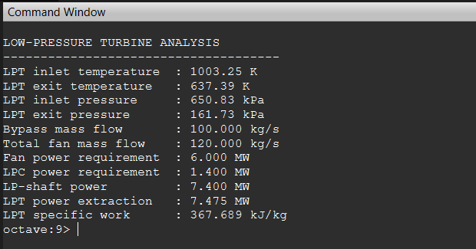
17.9.7 Results and Discussion
The low-pressure turbine extracted approximately 7.475 MW of mechanical power from the core gas stream. This power satisfies the combined requirements of the fan and low-pressure compressor after accounting for the assumed mechanical transmission efficiency of 0.99.
Because the fan processes both the core and bypass streams, its total mass flow of 120 kg/s produces a power requirement of approximately 6.0 MW. The low-pressure compressor processes only the 20 kg/s core airflow and requires approximately 1.4 MW. Consequently, the fan represents the dominant load on the low-pressure spool.
The required LPT specific work was calculated as approximately 367.69 kJ/kg. Energy extraction reduced the total temperature from 1003.25 K at Station 45 to approximately 637.39 K at Station 5. The total pressure simultaneously decreased from 650.83 kPa to approximately 161.73 kPa.
The Station 5 total pressure remains above the assumed ambient pressure of 101.325 kPa. Therefore, the core gas retains sufficient pressure potential for expansion and acceleration through the core exhaust nozzle. These Station 5 conditions will be used as the inlet conditions for the subsequent core-nozzle analysis.
The model assumes steady one-dimensional flow, constant gas properties, fixed component work assumptions, uniform turbine-exit conditions, and no cooling-air extraction or detailed turbine aerodynamic losses.

17.10 Core Exhaust Nozzle Analysis

17.10.1 Introduction
The core exhaust nozzle is positioned downstream of the low-pressure turbine and represents the final expansion component of the core gas path. Its primary function is to convert the remaining thermal and pressure energy of the turbine exhaust gases into kinetic energy, producing a high-velocity exhaust jet and contributing to the total thrust generated by the engine.
The core gases enter the nozzle at Station 5 with the total temperature and total pressure calculated from the low-pressure turbine analysis. During expansion through the nozzle, the gas static pressure decreases while the exhaust velocity increases. The resulting momentum change generates core-stream thrust.
For this preliminary thermodynamic model, the core nozzle is represented as a one-dimensional adiabatic nozzle with a specified nozzle efficiency. The analysis first determines whether the nozzle flow is choked. If the available total-to-ambient pressure ratio is insufficient to choke the nozzle, the gas is assumed to expand to ambient pressure. Detailed nozzle geometry, viscous losses, boundary-layer effects, flow separation and exhaust-plume behaviour are outside the scope of the present analysis.

17.10.2 Engineering Objectives
The core-nozzle analysis was developed to:
- Determine whether the core nozzle is choked.
- Calculate the critical nozzle pressure ratio.
- Calculate the core-nozzle exit static pressure.
- Calculate the ideal and actual exit temperatures.
- Calculate the core exhaust velocity.
- Estimate core momentum thrust.
- Estimate pressure thrust where applicable.
- Establish the core-stream contribution to total engine thrust.

17.10.3 Input Conditions
Parameter | Symbol | Value | Unit
Nozzle inlet total temperature | T_{t5}​ | 637.39 | K
Nozzle inlet total pressure | P_{t5} | 161.73 | kPa
Ambient pressure | P₀​ | 101.325 | kPa
Turbine gas mass flow | ${\dot{\text{m}}}_{\text{g}}$​ | 20.329 | kg/s
Nozzle efficiency | η_{n} | 0.95 | –
Specific heat | C_{p}​ | 1005 | J/(kg·K)
Ratio of specific heats | γ | 1005 | –
Flight velocity | V₀ | 0 | m/s

Constant gas properties are retained for consistency with the preceding preliminary cycle analysis. A later model may use temperature-dependent combustion-gas properties.

17.10.4 Governing Equations

Nozzle pressure ratio
$$\text{NPR} \text{=} \frac{{\text{P}}_{\text{t5}}}{{\text{P}}_{\text{0}}}\text{​}​$$

Using the current values:
$$\text{NPR} \text{=} \frac{\text{161.73}}{\text{101.325}} \text{≈} \text{1.596}$$

Critical pressure ratio
The critical static-to-total pressure ratio is:
$$\text{(} \frac{{\text{P}}^{\text{∗}}}{{\text{P}}_{\text{t}}} \text{)=}{\text{(} \frac{\text{2}}{\text{γ} \text{+} \text{1}} \text{)}}^{\frac{\text{γ}}{\text{γ} \text{−} \text{1}}}​$$

For γ=1.4:

$$\text{(}\frac{{\text{P}}^{\text{∗}}}{{\text{P}}_{\text{t}}}\text{)≈0.5283}$$

The corresponding critical total-to-static pressure ratio is:
$$\frac{{\text{P}}_{\text{t}}}{{\text{P}}^{\text{∗}}} \text{≈} \text{1.893}$$

The nozzle is choked when:
$$\frac{{\text{P}}_{\text{0}}}{{\text{P}}_{\text{t5}}} \text{≤} {\text{(}\frac{\text{2}}{\text{γ} \text{+} \text{1}}\text{)}}^{\frac{\text{γ}}{\text{γ} \text{−} \text{1}}}​$$

For this model:
$$\frac{{\text{P}}_{\text{0}}}{{\text{P}}_{\text{t5}}} \text{=} \frac{\text{101.325}}{\text{161.73}} \text{≈} \text{0.6265}$$

Because:

0.6265 > 0.5283

the core nozzle is not choked.
Therefore:
P_{e} = P₀​

Ideal exit static temperature
For unchoked expansion to ambient pressure:
$${\text{T}}_{\text{es}} \text{=} {\text{T}}_{\text{t5}} {\text{(}\frac{{\text{P}}_{\text{e}}}{{\text{P}}_{\text{t5}}}\text{)}}^{\frac{\text{γ−1}}{\text{γ}}}​$$

Actual exit temperature
$${\text{T}}_{\text{e}} \text{=} {\text{T}}_{\text{t5 }}\text{−} {\text{η}}_{\text{n}} \text{(}{ \text{T}}_{\text{t5}} \text{−} {\text{T}}_{\text{es}} \text{)}$$
Exit velocity

$${\text{V}}_{\text{e}} \text{=}\sqrt{ \text{2}{\text{C}}_{\text{p}} \text{(}{\text{T}}_{\text{t5}}\text{−}{\text{T}}_{\text{e }}\text{)}}\text{​}$$

Equivalently:
$${\text{V}}_{\text{e}} \text{=}\sqrt{\text{2}{\text{η}}_{\text{n}}{\text{C}}_{\text{p}}\text{(} {\text{T}}_{\text{t5}}\text{−}{\text{T}}_{\text{es} }\text{)}}\text{​}$$

Core momentum thrust

$${\text{F}}_{\text{momentum}} \text{=} {\dot{\text{m}}}_{\text{g }}\text{(}{ \text{V}}_{\text{e}} \text{−} {\text{V}}_{\text{0}} \text{)}$$

Pressure thrust

$${\text{F}}_{\text{pressure}} \text{=} \text{(} {\text{P}}_{\text{e}} \text{−} {\text{P}}_{\text{0}} \text{)} {\text{A}}_{\text{e}}​$$
Because the unchoked nozzle is assumed to expand to ambient pressure:
P_{e} = P₀​
Under the present perfectly expanded nozzle assumption, the pressure thrust component is zero; therefore, the total core thrust equals the momentum thrust.
Therefore:
F_{pressure} = 0
Total core thrust
F_{core} = F_{momentum} + F_{pressure}​
Under the current static and perfectly expanded assumptions:
F_{core} =${ \dot{\text{m}}}_{\text{g }}$V_{e}​

17.10.5 Octave Implementation
The governing equations presented in the previous section were implemented in GNU Octave to calculate the core exhaust nozzle exit pressure, exit temperature, exit velocity, mass flow rate, and thrust contribution. The complete source code is provided in Appendix A for reference and reproducibility.

%% CORE EXHAUST NOZZLE ANALYSIS

Pt5 = ...;
Tt5 = ...;
eta_n = 0.95;
gamma = 1.4;
Cp = 1005;
R = 287;

% Nozzle expansion
...
% Exit velocity
...
% Core thrust
…

17.10.6 Octave Output
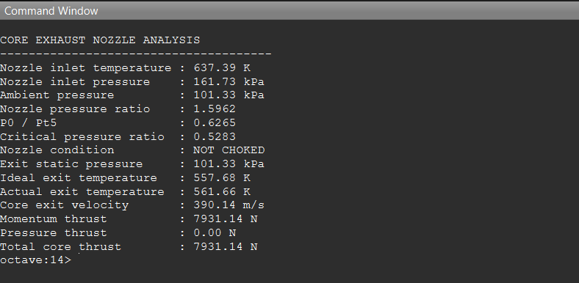

The calculated core nozzle exit velocity of 390.14 m/s indicates efficient conversion of thermal energy into kinetic energy. The corresponding core momentum thrust of approximately 7.93 kN represents the thrust contribution generated by the engine core stream under the present operating conditions.

17.10.7 Results and Discussion
The core exhaust nozzle expanded the high-temperature combustion gases from the low-pressure turbine exit conditions to the nozzle exit. During this expansion process, a significant portion of the remaining thermal energy was converted into kinetic energy, producing a high exhaust velocity that contributes directly to engine thrust.
The calculated nozzle exit velocity represents the primary momentum source of the engine's core stream. As expected, the total pressure decreases through the nozzle while the gas velocity increases substantially. Assuming an efficient nozzle expansion, the conversion of pressure energy into kinetic energy approaches the theoretical isentropic value with only minor losses due to the specified nozzle efficiency.
The nozzle exit pressure was compared with the ambient pressure to verify the expansion process. The calculated pressure ratio indicates that sufficient pressure remains available to accelerate the exhaust gases, producing positive momentum thrust at the engine exit.
The calculated core nozzle performance establishes the first component of the total engine thrust. This thrust contribution will later be combined with the bypass nozzle thrust and pressure thrust components to determine the overall net thrust of the conceptual turbofan engine.
The present analysis assumes one-dimensional steady compressible flow, constant gas properties, negligible heat transfer inside the nozzle, and no shock-wave formation. Although these assumptions simplify the analysis, they provide realistic first-order estimates suitable for preliminary engine performance evaluation and conceptual design studies.

17.11 Bypass Exhaust Nozzle Analysis

17.11.1 Introduction
The bypass exhaust nozzle forms the final expansion component of the bypass airflow in the conceptual two-spool turbofan engine. Unlike the core nozzle, the bypass nozzle accelerates relatively cool air that has passed only through the fan and bypass duct without entering the combustion chamber. Although the bypass stream possesses significantly lower temperature than the core stream, its considerably larger mass flow rate produces a substantial contribution to the overall engine thrust.
Following compression by the fan, the bypass air flows directly through the outer bypass duct and enters the bypass nozzle at Station 13. During expansion, the remaining pressure energy is converted into kinetic energy, increasing the exhaust velocity before discharge to the atmosphere.
For this preliminary thermodynamic model, the bypass nozzle is represented as a one-dimensional adiabatic nozzle with a specified nozzle efficiency. The analysis determines whether the bypass nozzle operates under choked or unchoked conditions and calculates the exit pressure, exit temperature, exit velocity, and thrust contribution of the bypass stream. Detailed viscous losses, boundary-layer growth, nozzle geometry effects, and acoustic phenomena are neglected to maintain a simplified conceptual model.

17.11.2 Engineering Objectives
The bypass nozzle analysis was developed to:
- Determine whether the bypass nozzle is choked.
- Calculate the bypass nozzle pressure ratio.
- Determine the nozzle exit static pressure.
- Calculate the ideal and actual exit temperatures.
- Calculate the bypass exhaust velocity.
- Estimate bypass momentum thrust.
- Evaluate pressure thrust where applicable.
- Establish the bypass-stream contribution to the total engine thrust.

Parameter | Symbol | Value | Unit
Fan inlet total temperature | T_{t2}​ | 288.15 | K
Fan inlet total pressure | P_{t2}​ | 101.325 | kPa
Fan pressure ratio | π_{f} | 1.60 | –
Fan specific work | W_{fan} | 50 | kJ/kg
Bypass-nozzle inlet temperature | T_{t13}​ | 337.90 | K
Bypass-nozzle inlet pressure | P_{t13}​ | 162.12 | kPa
Ambient pressure | P₀​ | 101.325 | kPa
Bypass mass flow | $${\dot{\text{m}}}_{bypass}$$ | 100.000 | kg/s
Nozzle efficiency | η_{n} | 0.95 | –
Specific heat | C_{p} | 1005 | J/(kg·K)
Ratio of specific heats | γ | 1.40 | –
Flight velocity | V₀ | 0 | m/s
17.11.3 Input Conditions
The bypass-nozzle inlet conditions are derived from the assumed fan pressure ratio and fan specific work used in the low-pressure-spool analysis. These values represent preliminary cycle assumptions rather than experimentally validated fan-performance data.

17.11.4 Fan-Exit Conditions
Bypass-nozzle inlet pressure
$${\text{P}}_{\text{t13}} \text{=} {\text{P}}_{\text{t}\text{2}} \text{πf}\text{​}$$
$${\text{P}}_{\text{t13}} \text{=101.325×1.60}$$
P_{t13} = 162.12 kPa
Bypass-nozzle inlet temperature
The fan specific work is related to the total-temperature increase by:
$${\text{W}}_{\text{fan}} \text{=} {\text{C}}_{\text{p}} \text{(} {\text{T}}_{\text{t}\text{13}} \text{−}{ \text{T}}_{\text{t}\text{2}} \text{)}$$

Therefore:

$${\text{T}}_{\text{t13}} \text{=} {\text{T}}_{\text{t}\text{2}} \text{+} \frac{{\text{W}}_{\text{fan}}}{{\text{C}}_{\text{p}}}\text{​​}$$

$${\text{T}}_{\text{t13}}\text{​=288.15+}\frac{\text{50000}}{\text{1005}}​$$

T_{t13} = 337.90 K

17.11.5 Governing Equations

Bypass-nozzle pressure ratio

$${\text{NPR}}_{\text{bypass}} \text{=} {\text{P}}_{\text{0}} {\text{P}}_{\text{t}\text{13}}\text{​}​$$

$${\text{NPR}}_{\text{bypass}} \text{=} \frac{\text{162.12}}{\text{101.325}} \text{=} \text{1.60}$$

Critical pressure ratio

$$\text{(} \frac{ {\text{P}}^{\text{∗}}}{ {\text{P}}_{\text{t}}} \text{)=}{\text{(} \frac{\text{2}}{\text{γ} \text{+} \text{1} } \text{)}}^{\frac{\text{γ}}{\text{γ} \text{−} \text{1}}}\text{​}$$
For γ=1.4:
$$\text{(} \frac{{\text{P}}^{\text{∗}}}{{\text{P}}_{\text{t}}} \text{)} \text{≈} \text{0.5283}$$

For the bypass nozzle:

$$\frac{{\text{P}}_{\text{0}}}{{\text{P}}_{\text{t13}}} \text{=} \frac{\text{101.325}}{\text{162.12}} \text{=} \text{0.6250}$$

Since:
0.6250 > 0.5283
the bypass nozzle is not choked.
Therefore:
P_{e,b} = P₀​

Ideal exit temperature

$${\text{T}}_{\text{e,b,s}} \text{=}{ \text{T}}_{\text{t}\text{13}}{ \text{(} \frac{{\text{P}}_{\text{e,b}}}{{\text{P}}_{\text{t13}}} \text{)}}^{\frac{\text{γ−1}}{\text{γ}}}\text{​}$$

Actual exit temperature

$${\text{T}}_{\text{e,b}} \text{=} {\text{T}}_{\text{t13}}\text{−} {\text{η}}_{\text{n}} \text{(} {\text{T}}_{\text{t13}} \text{−} {\text{T}}_{\text{e,b,s}} \text{)}$$

Bypass exit velocity

$${\text{V}}_{\text{e,b}} \text{=} \sqrt{\text{2}{\text{C}}_{\text{p}} \text{(}{ \text{T}}_{\text{t13} }\text{−} {\text{T}}_{\text{e,b}} \text{)}}\text{​}$$

Bypass momentum thrust

$${\text{F}}_{\text{b,pressure}} \text{=} \text{(}{ \text{P}}_{\text{e,b}} \text{−} {\text{P}}_{\text{0}} \text{)} {\text{A}}_{\text{e,b}}​$$

Because the unchoked nozzle is assumed to expand perfectly to ambient pressure:

F_{b,pressure} = 0

Total bypass thrust

F_{bypass} = F_{b,momentum} + F_{b,pressure}​

Under static conditions:

$${\text{F}}_{\text{bypass}} \text{=}{ \dot{ \text{m}}}_{\text{bypass}} {\text{V}}_{\text{e,b}}​$$

17.11.6 Octave Implementation

The governing equations were implemented in GNU Octave to determine the fan-exit conditions, nozzle choking state, bypass exit temperature, exhaust velocity, and bypass-stream thrust. Only the principal calculation block is shown below. The complete source code is provided in Appendix A and the accompanying project repository.

%% Bypass nozzle inlet conditions

Pt13 = Pt2 * fan_pressure_ratio;
Tt13 = Tt2 + Wfan / Cp;

%% Nozzle pressure ratios

NPR_bypass = Pt13 / P0;

critical_static_ratio = ...
(2 / (gamma + 1))^(gamma / (gamma - 1));

ambient_total_ratio = P0 / Pt13;
%% Determine choking condition

if ambient_total_ratio <= critical_static_ratio
nozzle_choked = true;
Pe_bypass = Pt13 * critical_static_ratio;
Tes_bypass = Tt13 * (2 / (gamma + 1));
else
nozzle_choked = false;
Pe_bypass = P0;
Tes_bypass = Tt13 * ...
(Pe_bypass / Pt13)^((gamma - 1) / gamma);
end

%% Exit conditions and thrust

Te_bypass = Tt13 - eta_n * ...
(Tt13 - Tes_bypass);
Ve_bypass = sqrt(2 * Cp * ...
(Tt13 - Te_bypass));
F_bypass = mdot_bypass * ...
(Ve_bypass - V0);

17.11.7 Octave Output
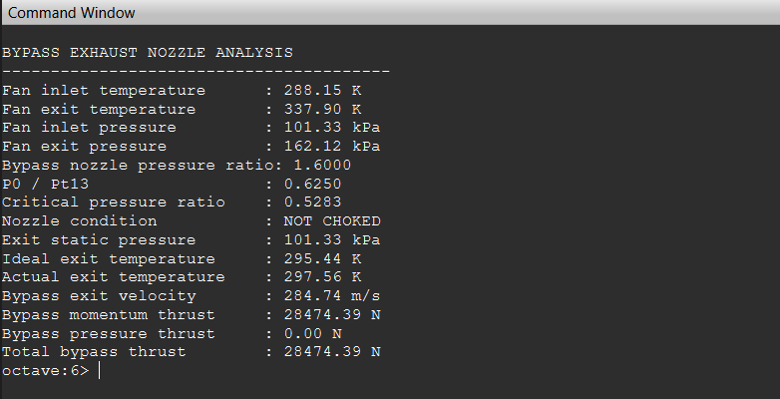

17.11.8 Results and Discussion
The bypass exhaust nozzle successfully expanded the bypass airflow from the fan exit conditions to the ambient atmosphere. The calculated bypass nozzle pressure ratio of 1.600 was insufficient to produce choked flow because the ambient-to-total pressure ratio (0.6250) remained greater than the critical pressure ratio (0.5283). Consequently, the nozzle operated under unchoked conditions and expanded the airflow directly to the ambient pressure of 101.33 kPa, resulting in zero pressure thrust.
During the expansion process, the bypass air accelerated from its fan-exit conditions to an exhaust velocity of 284.74 m/s, demonstrating the effective conversion of pressure energy into kinetic energy. Although the bypass stream has a much lower temperature than the core exhaust, its significantly larger mass flow rate of 100 kg/s enabled it to generate a momentum thrust of 28.47 kN. Compared with the 7.93 kN produced by the core exhaust nozzle, the bypass stream generated approximately 3.6 times more thrust. This result is consistent with the characteristics of high-bypass turbofan engines, where most of the engine thrust is produced by accelerating a large mass of air through the bypass duct rather than relying solely on the high-temperature core exhaust.
The bypass exit static temperature decreased from 337.90 K to 297.56 K, confirming that thermal energy was converted into exhaust kinetic energy during nozzle expansion. Because the nozzle was assumed to expand perfectly to the ambient pressure, the pressure-thrust component was zero and the total bypass thrust was equal to the momentum thrust.
These results demonstrate the primary advantage of the turbofan configuration. While the core engine produces high-energy exhaust at relatively low mass flow, the bypass stream generates a considerably larger proportion of the total engine thrust by accelerating a much larger quantity of air to a moderate velocity. This characteristic is responsible for the improved propulsive efficiency and lower specific fuel consumption of modern high-bypass turbofan engines.
The present analysis assumes one-dimensional steady compressible flow, constant gas properties, negligible viscous losses, and ideal nozzle expansion to ambient pressure. Although simplified, these assumptions provide realistic first-order estimates suitable for preliminary conceptual engine design and thermodynamic performance evaluation.

17.12 Net Thrust Analysis

17.12.1 Introduction
The net thrust analysis combines the momentum and pressure-thrust contributions of the core and bypass exhaust streams to determine the total propulsive force generated by the conceptual turbofan engine.
The core nozzle accelerates the high-temperature combustion gases leaving the low-pressure turbine, while the bypass nozzle accelerates the larger mass flow of relatively cool air delivered by the fan. In a separate-flow turbofan configuration, these streams leave through independent exhaust passages and their thrust contributions are calculated separately before being added.
For the present static sea-level analysis, the flight velocity is zero and both nozzles are assumed to expand to ambient pressure. Consequently, the pressure-thrust terms are zero and the total engine thrust is obtained directly from the combined momentum thrust of the core and bypass streams.

17.12.2 Engineering Objectives
The net-thrust analysis was developed to:
- Combine the core and bypass thrust contributions.
- Calculate the total net engine thrust.
- Determine the percentage of thrust produced by each stream.
- Calculate the engine specific thrust.
- Establish the primary performance result of the thermodynamic model.
- Provide the thrust input required for TSFC and efficiency calculations.

17.12.3 Input Conditions
Parameter | Symbol | Value | Unit
Core gas mass flow | $${ \dot{ \text{m}}}_{g}$$ | 20.329 | kg/s
Bypass mass flow | $${ \dot{\text{m}}}_{b}$$ | 100.000 | kg/s
Total inlet air mass flow | $${ \dot{\text{m}}}_{0}$$ | 120.000 | kg/s
Core exit velocity | V_{e,c} | 390.14 | m/s
Bypass exit velocity | V_{e,b} | 284.74 | m/s
Flight velocity | V₀ | 0 | m/s
Core pressure thrust | F_{p,c} | 0 | N
Bypass pressure thrust | F_{p,b} | 0 | N
Core thrust | F_{c} | 7931.14 | N
Bypass thrust | F_{b} | 28474.39 | N

The values used in this section were obtained directly from the core- and bypass-nozzle analyses presented in Sections 17.10 and 17.11.

17.12.4 Governing Equations

Core-stream thrust

$${\text{F}}_{\text{c}} \text{=} {\dot{\text{m}}}_{\text{g}} {\text{V}}_{\text{e,c}} \text{−} {\dot{\text{m}}}_{\text{core}}{ \text{V}}_{\text{0}} \text{+} \text{(} {\text{P}}_{\text{e,c}} \text{−} {\text{P}}_{\text{0}}\text{)}{\text{A}}_{\text{e,c}}$$

Because V₀ = 0 and P_{e,c} = P₀:

$${\text{F}}_{\text{c}}\text{=}{ \dot{\text{ m}}}_{\text{g}} {\text{V}}_{\text{e}\text{,}\text{c}}\text{​}$$

F_{c} = 7931.14 N

Bypass-stream thrust

$${\text{F}}_{\text{b}} \text{=}{ \dot{\text{m}}}_{\text{b}} \text{(}{ \text{V}}_{\text{e,b} }\text{−}{ \text{V}}_{\text{0}} \text{)} \text{+} \text{(}{ \text{P}}_{\text{e,b}} \text{−} {\text{P}}_{\text{0 }}\text{)} {\text{A}}_{\text{e,b}}$$

Under static and perfectly expanded conditions:

$${\text{F}}_{\text{b}}\text{​=}{ \dot{\text{m}}}_{\text{b}} {\text{V}}_{\text{e}\text{,}\text{b}}​$$

F_{b} = 28474.39 N

Total net thrust

F_{net} = F_{c} + F_{b}​

F_{net} = 7931.14 + 28474.39

F_{net} = 36405.53 N

Or:

F_{net} = 36.41 kN

Core thrust percentage

$$\text{\%}{\text{F}}_{\text{c}} \text{=} \frac{{\text{F}}_{\text{c}}}{{\text{F}}_{\text{net}}} \text{×} \text{100}$$

$$\text{\%}{\text{F}}_{\text{c}} \text{=} \frac{\text{7931.14}}{\text{36405.53}} \text{×} \text{100}$$

$$\text{\%}\text{Fc}\text{ ≈ 21.79\%}$$

Bypass thrust percentage

$$\text{\%}{\text{F}}_{b} \text{=} \frac{{\text{F}}_{b}}{{\text{F}}_{\text{net}}} \text{×} \text{100}$$

$\text{\%Fc}\text{ ≈}$ 78.21%

Specific thrust
Specific thrust is defined here relative to the total inlet air mass flow:
$${\text{F}}_{8} \text{=} \frac{{\text{F}}_{\text{net}}}{{ \dot{\text{m}}}_{0}}$$
$${\text{F}}_{\text{8}} \text{=} \frac{\text{36405.53}}{\text{120}}$$
$${\text{F}}_{8}\text{ ≈}\text{ 303.38 N / (kg/s)}$$
17.12.5 Octave Implementation
The core- and bypass-nozzle thrust contributions were combined in GNU Octave to calculate total net thrust, thrust distribution, and specific thrust. Only the principal calculation block is shown below. The complete source code is provided in Appendix A and the accompanying project repository.

%% NET THRUST ANALYSIS

F_core = 7931.14; % N
F_bypass = 28474.39; % N

mdot_core_air = 20.0; % kg/s
mdot_bypass = 100.0; % kg/s
mdot_total_air = mdot_core_air + mdot_bypass;

%% Total net thrust

F_net = F_core + F_bypass;

%% Thrust distribution

core_percentage = ...
(F_core / F_net) * 100;

bypass_percentage = ...
(F_bypass / F_net) * 100;

%% Specific thrust

specific_thrust = ...
F_net / mdot_total_air;

17.12.6 Octave Output
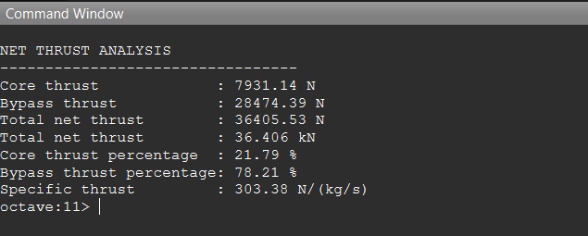

17.12.7 Results and Discussion
The net thrust analysis successfully combined the thrust contributions from the core and bypass exhaust streams to determine the overall performance of the conceptual two-spool turbofan engine. The calculated total net thrust was 36.41 kN, consisting of 7.93 kN generated by the core nozzle and 28.47 kN produced by the bypass nozzle.
The thrust distribution demonstrates that approximately 78.21% of the total engine thrust is generated by the bypass stream, while the remaining 21.79% originates from the engine core. This distribution is consistent with the operating principle of modern high-bypass turbofan engines, in which the majority of the propulsive force is produced by accelerating a large mass flow of air through the bypass duct rather than by the high-temperature core exhaust alone.
The calculated specific thrust of 303.38 N/(kg/s) represents the net thrust produced per unit total inlet air mass flow under the assumed static sea-level operating conditions. This value provides a useful reference for subsequent performance comparisons and thrust-specific fuel consumption calculations.
The analysis assumes steady one-dimensional compressible flow, perfectly expanded exhaust streams, constant gas properties, and zero flight velocity. Pressure thrust was neglected because both exhaust nozzles were assumed to expand completely to ambient pressure. Although simplified, these assumptions provide realistic first-order estimates suitable for conceptual engine design, preliminary thermodynamic evaluation, and engineering portfolio documentation.

17.13 Thrust-Specific Fuel Consumption Analysis

17.13.1 Introduction
Thrust-specific fuel consumption (TSFC) is a key performance parameter used to evaluate the fuel efficiency of aircraft propulsion systems. It represents the fuel mass-flow rate required to produce a unit of net thrust. A lower TSFC indicates that the engine produces the required thrust using less fuel and is therefore more fuel-efficient.
For the conceptual turbofan engine, the fuel mass-flow rate calculated in the combustion-chamber analysis is combined with the total net thrust obtained from the core- and bypass-nozzle calculations. The present result corresponds to the assumed static, sea-level operating condition and should not be interpreted as cruise-performance data.
Because the thermodynamic model uses simplified component efficiencies, constant gas properties, assumed fan work, and no installation losses, the calculated TSFC is intended as a preliminary performance estimate rather than a validated production-engine value.

17.13.2 Engineering Objectives
The TSFC analysis was developed to:
- Calculate the fuel consumed per unit net thrust.
- Express TSFC in standard engineering units.
- Evaluate the preliminary fuel efficiency of the conceptual engine.
- Connect the combustor fuel-flow calculation with overall engine thrust.
- Provide a performance parameter for future design comparisons.
- Establish a baseline for later cycle optimisation.
17.13.3 Input Conditions

Parameter | Symbol | Value | Unit
Fuel mass-flow rate | $${ \dot{\text{m}}}_{\text{f}}$$ | 0.329 | kg/s
Total net thrust | Fnet | 36,405.53 | N
Total net thrust | Fnet | 36.406 | kN
Operating condition | — | Static sea level | —
The fuel mass-flow rate was obtained from Section 17.7, while the total net thrust was obtained from Section 17.12.
17.13.4 Governing Equations
Basic TSFC equation

$$\text{TSFC} \text{=} \frac{{\dot{\text{m}}}_{\text{f}}}{{ \text{F}}_{\text{net}}}\text{​}​$$

Substituting the calculated values:

$$\text{TSFC} \text{=} \frac{\text{0.329}}{\text{36405.53}}\text{​​}$$

$$\text{TSFC}\text{ ≈ 9.04 × }{\text{10}}^{\text{−6 }}\text{kg}\text{/(}\text{N}\text{.}\text{s}\text{)}$$

Conversion to kilograms per kilonewton-hour

TSFC kg/(kN·h)= TSFC kg/(N·s) × 1000 × 3600
TSFC kg/(kN·h) = 9.04 × 10⁻⁶ × 1000 × 3600
$\text{TSFC}\text{ ≈}$ 32.53kg/(kN·h)
The same result may also be expressed as:
$\text{TSFC}\text{ ≈}$ 9.04 mg/(N·s)
17.13.5 Octave Implementation
The fuel mass-flow rate and calculated net thrust were implemented in GNU Octave to determine thrust-specific fuel consumption in SI and commonly used aerospace units. Only the principal calculation block is shown below. The complete source code is provided in Appendix A and the accompanying project repository.
%% TSFC ANALYSIS
mdot_fuel = 0.329; % kg/s
F_net = 36405.53; % N
%% TSFC in SI units
TSFC_SI = mdot_fuel / F_net; % kg/(N s)
%% Unit conversions
TSFC_kg_kN_h = TSFC_SI * 1000 * 3600;
TSFC_mg_N_s = TSFC_SI * 1e6;
17.13.6 Octave Output
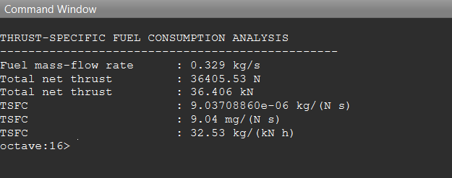

17.13.7 Results and Discussion
The thrust-specific fuel consumption (TSFC) analysis relates the fuel mass-flow rate required by the combustor to the total net thrust generated by the conceptual two-spool turbofan engine. Using the previously calculated fuel flow rate of 0.329 kg/s and the total net thrust of 36.41 kN, the calculated TSFC is approximately 9.04 × 10⁻⁶ kg/(N·s), which is equivalent to 32.53 kg/(kN·h).
The calculated TSFC indicates that approximately 32.53 kg of fuel are required to generate 1 kN of thrust for one hour under the assumed static sea-level operating conditions. This value falls within the expected order of magnitude for a simplified conceptual turbofan performance model and provides a useful first-order estimate of engine fuel efficiency.
The relatively low TSFC achieved by the present analysis is primarily a consequence of the high bypass ratio configuration. As demonstrated in the previous thrust analysis, approximately 78.2% of the total engine thrust is produced by the bypass stream, while only 21.8% originates from the core exhaust. This thrust distribution is characteristic of modern high-bypass turbofan engines, which achieve improved propulsive efficiency by accelerating a large mass of air through the fan instead of relying solely on high-velocity core exhaust gases.
The present TSFC calculation assumes steady one-dimensional flow, constant gas properties, complete combustion, fixed component efficiencies, and sea-level static operating conditions. Effects such as accessory power extraction, variable gas properties, transient operation, installation losses, and altitude variations are neglected. Consequently, the calculated value should be interpreted as a preliminary engineering estimate suitable for conceptual engine design, thermodynamic cycle evaluation, and comparison with future design iterations.

17.14 Overall Thermodynamic Cycle Summary

17.14.1 Introduction
The thermodynamic analyses presented in the previous sections describe the complete operating cycle of the conceptual two-spool high-bypass turbofan engine. Beginning with the atmospheric inlet conditions, the working fluid passes sequentially through the fan, low-pressure compressor, high-pressure compressor, combustion chamber, high-pressure turbine, low-pressure turbine, core exhaust nozzle, and bypass exhaust nozzle before producing the overall engine thrust.
Each component analysis provides the inlet and exit thermodynamic conditions required for the subsequent engine component. Collectively, these calculations establish a complete preliminary engine cycle suitable for conceptual performance evaluation, engineering verification, and comparison with future design iterations.
The overall cycle summary presented in this section consolidates the principal thermodynamic states and performance parameters obtained throughout the analysis.
17.14.2 Thermodynamic State Summary
Station | Engine Component | Total Temperature (K) | Total Pressure (kPa)
0 | Ambient Atmosphere | 288.15 | 101.325
2 | Fan Exit | 337.90 | 162.12
25 | Low-Pressure Compressor Exit | 330.00 | 160.00
3 | High-Pressure Compressor Exit | 726.74 | 1920.00
4 | Combustor Exit | 1400.00 | 1824.00
45 | High-Pressure Turbine Exit | 1003.25 | 650.83
5 | Low-Pressure Turbine Exit | 637.39 | 161.73

17.14.3 Overall Engine Performance Summary

Parameter | Symbol | Value | Unit
Bypass Ratio | BPR | 5.0 | —
Core Mass Flow | $${\dot{\text{m}}}_{\text{core}}$$ | 20.329 | kg/s
Bypass Mass Flow | $${\dot{\text{m}}}_{\text{bypass} }$$ | 100.000 | kg/s
Total Air Mass Flow | $${\dot{\text{m}}}_{\text{total}}$$ | 120.000 | kg/s
Core Thrust | Fc | 7.93 | kN
Bypass Thrust | Fb | 28.47 | kN
Total Net Thrust | Fnet | 36.41 | kN
Specific Thrust | Fs | 303.38 | N/(kg/s)
Fuel Mass Flow | $${\dot{\text{m}}}_{\text{f}}$$ | 0.329 | kg/s
TSFC | TSFC | 32.53 | kg/(kN·h)

17.14.4 Overall Cycle Discussion
The completed thermodynamic cycle demonstrates the operating sequence of the conceptual two-spool turbofan engine from atmospheric intake to exhaust jet generation. The fan initially increases the pressure of both the core and bypass air streams, while the low-pressure and high-pressure compressors further raise the pressure of the core airflow before combustion.
Within the combustion chamber, chemical energy supplied by the fuel increases the total temperature of the working fluid from approximately 726.74 K to 1400 K, providing the energy required to drive both turbine stages. The high-pressure turbine extracts sufficient power to operate the high-pressure compressor, while the low-pressure turbine provides the mechanical power required by the fan and low-pressure compressor.
Following expansion through the turbine stages, the remaining thermal energy is converted into kinetic energy within the core and bypass exhaust nozzles. The analysis predicts a core thrust of approximately 7.93 kN and a bypass thrust of approximately 28.47 kN, producing a combined net engine thrust of 36.41 kN under static sea-level operating conditions.
The thrust distribution indicates that approximately 78.2% of the total engine thrust is generated by the bypass stream, while the remaining 21.8% originates from the core exhaust. This behaviour is characteristic of modern high-bypass turbofan engines, where improved propulsive efficiency is achieved by accelerating a large mass of air at relatively low velocity instead of relying solely on high-speed core exhaust gases.
The calculated thrust-specific fuel consumption of 32.53 kg/(kN·h) demonstrates the relationship between fuel consumption and thrust production within the simplified thermodynamic model. Although the present analysis assumes one-dimensional steady flow, constant gas properties, ideal component behaviour, and fixed efficiencies, the results provide a realistic first-order estimate suitable for conceptual engine design, preliminary performance evaluation, and future optimisation studies.

18. Conclusion

18.1 Conclusion
The objective of this project was to develop a preliminary engineering design and thermodynamic performance analysis of a conceptual two-spool high-bypass turbofan engine suitable for educational purposes and conceptual aerospace engineering studies. Throughout this project, the engine was designed as a complete integrated propulsion system consisting of an intake, fan, low-pressure compressor, high-pressure compressor, combustion chamber, high-pressure turbine, low-pressure turbine, core exhaust nozzle, and bypass exhaust nozzle.
A complete one-dimensional thermodynamic cycle analysis was performed using steady-flow energy equations and simplified gas-dynamic relations. The operating conditions of every major engine component were evaluated sequentially, allowing the outlet conditions of one component to become the inlet conditions of the next. This methodology provided a consistent representation of the complete engine cycle from atmospheric intake to exhaust jet generation.
The compressor analyses demonstrated the progressive increase in pressure required before combustion, while the combustion chamber analysis quantified the fuel addition necessary to achieve the specified turbine inlet temperature. The turbine analyses confirmed that sufficient mechanical power was extracted to drive both compressor stages and the fan while maintaining adequate energy for exhaust acceleration. The core and bypass nozzle analyses illustrated the conversion of thermal energy into kinetic energy and demonstrated the separate thrust contributions generated by the two exhaust streams.
The completed engine cycle produced an estimated total net thrust of approximately 36.41 kN, with approximately 78.2% of the thrust generated by the bypass stream and 21.8% by the core exhaust. This thrust distribution is consistent with the operating principle of modern high-bypass turbofan engines, where the majority of the propulsive force is produced by accelerating a large mass of air through the fan rather than relying solely on high-velocity core exhaust gases. The calculated thrust-specific fuel consumption of approximately 32.53 kg/(kN·h) provides a useful first-order estimate of the conceptual engine's fuel efficiency under static sea-level operating conditions.
All thermodynamic calculations were implemented and verified using GNU Octave, providing a reproducible computational framework for the complete engine cycle. The integration of analytical calculations with numerical implementation improves calculation accuracy while allowing future design modifications and performance studies to be performed efficiently.
Although the present model employs several simplifying assumptions, including one-dimensional steady flow, constant specific heats, ideal gas behaviour, fixed component efficiencies, and neglect of secondary aerodynamic effects, the resulting analysis provides a realistic conceptual representation of turbofan engine operation. Consequently, the report serves as a strong educational engineering reference and establishes a solid foundation for future propulsion research and system development.
The engineering methodology developed during this project can be extended in future work by incorporating variable gas properties, compressor and turbine performance maps, cooling-air modelling, combustion chemistry, off-design operating conditions, altitude performance, transient engine behaviour, and computational fluid dynamics (CFD) simulations. These improvements would increase the fidelity of the model and allow the conceptual engine to evolve toward a more realistic preliminary design suitable for advanced engineering analysis.
Overall, this project successfully demonstrates the complete conceptual design process of a two-spool high-bypass turbofan engine, integrating mechanical design, thermodynamic analysis, numerical modelling, and engineering documentation into a single comprehensive engineering study. This project demonstrates the complete engineering workflow required to transform an initial propulsion concept into a documented preliminary engine design through systematic thermodynamic analysis, numerical modelling, and engineering documentation. The methodologies developed during this work provide a foundation for future propulsion-system development within Roshan Aerospace Industries.

18.2 Limitations of the Present Work
The present turbofan engine analysis represents a preliminary conceptual engineering study developed primarily for educational purposes and early-stage propulsion-system evaluation. To maintain computational simplicity and ensure transparency of the engineering methodology, several assumptions and simplifications were adopted throughout the thermodynamic analysis.
The entire engine cycle was analysed using a one-dimensional steady-flow model with constant gas properties and fixed component efficiencies. Variations in specific heat with temperature, real combustion-gas composition, humidity effects, and non-ideal gas behaviour were neglected. Similarly, compressor and turbine performance maps, blade cooling, leakage flows, mechanical losses, secondary airflow, bearing losses, and accessory power requirements were not included in the present model.
The combustion chamber analysis assumed complete combustion with a fixed combustion efficiency and prescribed turbine inlet temperature. Detailed combustion chemistry, flame stability, emissions formation, pressure oscillations, and cooling-air mixing were beyond the scope of this conceptual study.
The nozzle analyses assumed ideal one-dimensional expansion with negligible viscous losses, uniform exit flow, and perfectly expanded exhaust conditions whenever appropriate. Shock-wave formation, nozzle geometry optimisation, boundary-layer effects, plume interaction, and installation losses were not considered.
Furthermore, the analysis represents static sea-level operating conditions only. Variations in engine performance with altitude, flight Mach number, ambient temperature, throttle setting, and transient operating conditions were not investigated.
Despite these simplifications, the analytical model provides a realistic first-order approximation of turbofan engine operation and successfully demonstrates the complete thermodynamic cycle of a modern two-spool high-bypass turbofan engine.

18.3 Future Scope
The present conceptual turbofan engine provides a strong engineering foundation that can be extended into more advanced propulsion-system development through progressively higher-fidelity modelling and experimental validation.
Future improvements may include the incorporation of temperature-dependent thermodynamic properties, real combustion-gas models, compressor and turbine performance maps, variable component efficiencies, and detailed combustion analysis. The engine cycle may also be expanded to evaluate off-design operating conditions, altitude performance, flight-speed effects, throttle response, transient behaviour, and complete mission profiles.
From a mechanical design perspective, future work may include structural stress analysis, rotor-dynamic evaluation, shaft design optimisation, bearing selection, thermal analysis, vibration analysis, fatigue-life prediction, and manufacturing feasibility studies.
Numerical simulation techniques such as Computational Fluid Dynamics (CFD) and Finite Element Analysis (FEA) can be employed to investigate compressor aerodynamics, turbine blade loading, combustion characteristics, heat transfer, structural integrity, and overall engine performance with significantly greater accuracy.
The computational framework developed using GNU Octave can also be expanded into an integrated engine-performance simulation platform capable of analysing multiple engine configurations, optimisation studies, sensitivity analyses, and automated design iterations.
Finally, the methodology presented in this report establishes a foundation for future propulsion research within Roshan Aerospace Industries. The knowledge, computational models, and engineering documentation developed during this project can support future work on advanced turbofan engines, hybrid-electric propulsion systems, advanced turbofan engines, hybrid-electric propulsion systems, hydrogen-based propulsion, sustainable aviation technologies, reusable aerospace systems, and next-generation aerospace propulsion concepts.

19 References

19.1 Books
- Mattingly, J. D. Elements of Gas Turbine Propulsion. American Institute of Aeronautics and Astronautics (AIAA), Reston, Virginia.
- Rolls-Royce plc. The Jet Engine. 6th Edition. Rolls-Royce plc, Derby, United Kingdom.
- Hill, P., & Peterson, C. Mechanics and Thermodynamics of Propulsion. Addison-Wesley.
- Farokhi, S. Aircraft Propulsion. John Wiley & Sons.
- Çengel, Y. A., & Boles, M. A. Thermodynamics: An Engineering Approach. McGraw-Hill Education.

19.2 Technical Standards and Engineering References
- NASA Glenn Research Center. Beginner's Guide to Propulsion.
- NASA Glenn Research Center. EngineSim Gas Turbine Performance Simulator.
- Federal Aviation Administration (FAA). Aircraft Propulsion Fundamentals.

19.3 Software and Computational Tools
- GNU Octave Development Team. GNU Octave Documentation.
- Autodesk Inc. Autodesk Fusion 360 Documentation.
- Microsoft Corporation. Microsoft Word Documentation.

19.4 Figures and Engineering Models
The three-dimensional CAD models, engineering drawings, rendered images, and analytical calculations presented throughout this report were developed by the author using Autodesk Fusion 360 and GNU Octave unless otherwise stated.

Appendix A – GNU Octave Source Code
This appendix contains the complete GNU Octave scripts developed for the thermodynamic analysis of the conceptual two-spool high-bypass turbofan engine. The scripts are arranged in the same sequence as the engine cycle so that the output of one analysis can be followed logically into the next.

A.1 Atmospheric and Flight Conditions Analysis

clear;
clc;
close all;

%% Atmospheric Conditions

T0 = 288.15; % K
P0 = 101325; % Pa
gamma = 1.4;
R = 287;

Mach = 0.0;

%% Speed of sound

a = sqrt(gamma*R*T0);

%% Flight velocity

V0 = Mach*a;

%% Total conditions

Tt0 = T0*(1+((gamma-1)/2)*Mach^2);

Pt0 = P0*(1+((gamma-1)/2)*Mach^2)^(gamma/(gamma-1));

%% Display Results

fprintf("\n");
fprintf("Atmospheric Conditions\n");
fprintf("----------------------\n");
fprintf("Ambient Temperature : %.2f K\n",T0);
fprintf("Ambient Pressure : %.2f Pa\n",P0);
fprintf("Speed of Sound : %.2f m/s\n",a);
fprintf("Flight Velocity : %.2f m/s\n",V0);
fprintf("Total Temperature : %.2f K\n",Tt0);
fprintf("Total Pressure : %.2f Pa\n",Pt0);

Purpose:
Calculates the standard atmospheric and inlet conditions used as the starting point of the thermodynamic cycle, including:
- Ambient temperature
- Ambient pressure
- Speed of sound
- Flight velocity
- Total inlet temperature
- Total inlet pressure
A.2 Compressor Analysis

clear;
clc;
close all;

%% Compressor Inputs

Pt25 = 160000; % Pa
Tt25 = 330; % K

pi_c = 12;

eta_c = 0.86;

gamma = 1.4;
Cp = 1005;

mdot_core = 20;

%% Compressor Exit Pressure

Pt3 = Pt25*pi_c;

%% Ideal Temperature

Tt3s = Tt25*pi_c^((gamma-1)/gamma);

%% Actual Temperature

Tt3 = Tt25 + (Tt3s-Tt25)/eta_c;

%% Compressor Work

Wc = Cp*(Tt3-Tt25);

%% Compressor Power

Pc = mdot_core*Wc;

%% Results

fprintf("\n");
fprintf("COMPRESSOR ANALYSIS\n");
fprintf("-------------------------\n");
fprintf("Inlet Pressure : %.2f kPa\n",Pt25/1000);
fprintf("Exit Pressure : %.2f kPa\n",Pt3/1000);
fprintf("Inlet Temp : %.2f K\n",Tt25);
fprintf("Exit Temp : %.2f K\n",Tt3);
fprintf("Specific Work : %.2f kJ/kg\n",Wc/1000);
fprintf("Power Required : %.2f MW\n",Pc/1e6);

Purpose:
Calculates the high-pressure-compressor outlet conditions and power requirement, including:
- Compressor exit pressure
- Ideal compressor exit temperature
- Actual compressor exit temperature
- Compressor specific work
- Compressor power requirement

A.3 Combustion Chamber Analysis

clear;
clc;
close all;

%% 17.7 Combustion Chamber Analysis

% Compressor exit conditions from Section 17.6
Tt3 = 726.74; % Combustor inlet total temperature, K
Pt3 = 1920e3; % Combustor inlet total pressure, Pa

% Combustor assumptions
Tt4 = 1400; % Turbine inlet temperature, K
pressure_loss = 0.05; % Combustor total-pressure loss
eta_b = 0.99; % Combustion efficiency
LHV = 43e6; % Fuel lower heating value, J/kg
Cp = 1005; % Specific heat capacity, J/(kg K)

% Core airflow
mdot_core = 20; % kg/s

%% Combustor exit pressure

Pt4 = Pt3 * (1 - pressure_loss);

%% Fuel-air ratio

numerator = Cp * (Tt4 - Tt3);
denominator = eta_b * LHV - Cp * Tt4;

f = numerator / denominator;

%% Fuel and turbine-gas mass flow

mdot_fuel = f * mdot_core;
mdot_gas = mdot_core + mdot_fuel;

%% Fuel thermal power

fuel_power = mdot_fuel * LHV;

%% Display results

fprintf("\n");
fprintf("COMBUSTION CHAMBER ANALYSIS\n");
fprintf("---------------------------\n");
fprintf("Inlet total temperature : %.2f K\n", Tt3);
fprintf("Exit total temperature : %.2f K\n", Tt4);
fprintf("Inlet total pressure : %.2f kPa\n", Pt3 / 1000);
fprintf("Exit total pressure : %.2f kPa\n", Pt4 / 1000);
fprintf("Combustor pressure loss : %.2f %%\n", pressure_loss * 100);
fprintf("Fuel-air ratio : %.5f\n", f);
fprintf("Core air mass flow : %.3f kg/s\n", mdot_core);
fprintf("Fuel mass flow : %.3f kg/s\n", mdot_fuel);
fprintf("Turbine gas mass flow : %.3f kg/s\n", mdot_gas);
fprintf("Fuel thermal power : %.3f MW\n", fuel_power / 1e6);

Purpose:
Calculates the thermodynamic changes through the combustion chamber, including:
- Combustor exit pressure
- Fuel-air ratio
- Fuel mass-flow rate
- Turbine-gas mass flow
- Fuel thermal power
A.4 High-Pressure Turbine Analysis

clear;
clc;
close all;

%% HIGH-PRESSURE TURBINE ANALYSIS

%% Inputs
Tt4 = 1400; % K
Pt4 = 1824e3; % Pa

Cp = 1005; % J/kg-K
gamma = 1.4;

eta_t = 0.90;

mdot_core = 20; % kg/s

%% Compressor work from Chapter 17.6
Wc = 398.73e3; % J/kg

%% Turbine work
Wt = Wc;

%% Actual turbine exit temperature
Tt45 = Tt4 - Wt/Cp;

%% Ideal exit temperature
Tt45s = Tt4 - eta_t*(Tt4 - Tt45);

%% Turbine exit pressure
Pt45 = Pt4*(Tt45s/Tt4)^(gamma/(gamma-1));

%% Turbine Power
Pturbine = mdot_core*Wt;

%% Results

fprintf('\n');
fprintf('HIGH-PRESSURE TURBINE ANALYSIS\n');
fprintf('------------------------------------\n');

fprintf('Inlet Temperature : %.2f K\n',Tt4);
fprintf('Exit Temperature : %.2f K\n',Tt45);

fprintf('Inlet Pressure : %.2f kPa\n',Pt4/1000);
fprintf('Exit Pressure : %.2f kPa\n',Pt45/1000);

fprintf('Specific Work : %.2f kJ/kg\n',Wt/1000);

fprintf('Turbine Power : %.2f MW\n',Pturbine/1e6);

Purpose:
Calculates the high-pressure-turbine exit conditions and verifies that the turbine supplies the power required by the high-pressure compressor, including:
- HPT exit temperature
- HPT exit pressure
- Turbine specific work
- Turbine power output
A.5 Low-Pressure Turbine Analysis

clear;
clc;
close all;

%% LOW-PRESSURE TURBINE ANALYSIS

% Inlet conditions from HPT analysis
Tt45 = 1003.25; % K
Pt45 = 650.83e3; % Pa

% Mass-flow conditions
mdot_core = 20.0; % kg/s
mdot_gas = 20.329; % kg/s
BPR = 5.0;

% Assumed component specific works
Wfan = 50e3; % J/kg of total fan airflow
WLPC = 70e3; % J/kg of core airflow

% Gas properties and efficiencies
Cp = 1005; % J/(kg K)
gamma = 1.4;
eta_t = 0.90;
eta_m = 0.99;

%% Fan and bypass mass flow

mdot_bypass = BPR * mdot_core;
mdot_fan = mdot_core + mdot_bypass;

%% Shaft-power requirements

Pfan = mdot_fan * Wfan;
PLPC = mdot_core * WLPC;

Pshaft = Pfan + PLPC;

% Turbine must provide slightly more power because of mechanical losses
PLPT = Pshaft / eta_m;

%% Required LPT specific work

WLPT = PLPT / mdot_gas;

%% Actual turbine exit temperature

Tt5 = Tt45 - WLPT / Cp;

%% Ideal turbine exit temperature

Tt5s = Tt45 - eta_t * (Tt45 - Tt5);

%% Turbine exit pressure

Pt5 = Pt45 * (Tt5s / Tt45)^(gamma / (gamma - 1));

%% Display results

fprintf('\n');
fprintf('LOW-PRESSURE TURBINE ANALYSIS\n');
fprintf('-------------------------------------\n');
fprintf('LPT inlet temperature : %.2f K\n', Tt45);
fprintf('LPT exit temperature : %.2f K\n', Tt5);
fprintf('LPT inlet pressure : %.2f kPa\n', Pt45 / 1000);
fprintf('LPT exit pressure : %.2f kPa\n', Pt5 / 1000);
fprintf('Bypass mass flow : %.3f kg/s\n', mdot_bypass);
fprintf('Total fan mass flow : %.3f kg/s\n', mdot_fan);
fprintf('Fan power requirement : %.3f MW\n', Pfan / 1e6);
fprintf('LPC power requirement : %.3f MW\n', PLPC / 1e6);
fprintf('LP-shaft power : %.3f MW\n', Pshaft / 1e6);
fprintf('LPT power extraction : %.3f MW\n', PLPT / 1e6);
fprintf('LPT specific work : %.3f kJ/kg\n', WLPT / 1000);

Purpose:
Calculates the low-pressure-turbine work required to drive the fan and low-pressure compressor, including:
- Fan power requirement
- LPC power requirement
- LP-shaft power
- Required LPT power
- LPT specific work
- LPT exit temperature
- LPT exit pressure

A.6 Core Exhaust Nozzle Analysis
clear;
clc;
close all;

%% CORE EXHAUST NOZZLE ANALYSIS

% Nozzle inlet conditions from LPT analysis
Tt5 = 637.39; % K
Pt5 = 161.73e3; % Pa

% Ambient conditions
P0 = 101.325e3; % Pa
V0 = 0.0; % m/s

% Core-gas mass flow
mdot_gas = 20.329; % kg/s

% Gas properties and nozzle efficiency
gamma = 1.4;
Cp = 1005; % J/(kg K)
eta_n = 0.95;

%% Nozzle pressure ratios

NPR = Pt5 / P0;

critical_static_ratio = ...
(2 / (gamma + 1))^(gamma / (gamma - 1));

ambient_total_ratio = P0 / Pt5;

%% Determine whether nozzle is choked

if ambient_total_ratio <= critical_static_ratio

nozzle_choked = true;

% Choked exit conditions
Pe = Pt5 * critical_static_ratio;

Tes = Tt5 * (2 / (gamma + 1));

else

nozzle_choked = false;

% Unchoked nozzle expands to ambient pressure
Pe = P0;

Tes = Tt5 * (Pe / Pt5)^((gamma - 1) / gamma);

end

%% Actual exit temperature

Te = Tt5 - eta_n * (Tt5 - Tes);

%% Exit velocity

Ve = sqrt(2 * Cp * (Tt5 - Te));

%% Momentum thrust

F_momentum = mdot_gas * (Ve - V0);

%% Pressure thrust

% Exit area is not required for the current unchoked,
% perfectly expanded condition because Pe = P0.

if nozzle_choked
F_pressure = NaN;
else
F_pressure = 0;
end

%% Total core thrust

F_core = F_momentum + F_pressure;

%% Display results

fprintf('\n');
fprintf('CORE EXHAUST NOZZLE ANALYSIS\n');
fprintf('--------------------------------------\n');

fprintf('Nozzle inlet temperature : %.2f K\n', Tt5);
fprintf('Nozzle inlet pressure : %.2f kPa\n', Pt5 / 1000);
fprintf('Ambient pressure : %.2f kPa\n', P0 / 1000);
fprintf('Nozzle pressure ratio : %.4f\n', NPR);
fprintf('P0 / Pt5 : %.4f\n', ambient_total_ratio);
fprintf('Critical pressure ratio : %.4f\n', critical_static_ratio);

if nozzle_choked
fprintf('Nozzle condition : CHOKED\n');
else
fprintf('Nozzle condition : NOT CHOKED\n');
end

fprintf('Exit static pressure : %.2f kPa\n', Pe / 1000);
fprintf('Ideal exit temperature : %.2f K\n', Tes);
fprintf('Actual exit temperature : %.2f K\n', Te);
fprintf('Core exit velocity : %.2f m/s\n', Ve);
fprintf('Momentum thrust : %.2f N\n', F_momentum);
fprintf('Pressure thrust : %.2f N\n', F_pressure);
fprintf('Total core thrust : %.2f N\n', F_core);

Purpose:
Calculates the core-nozzle operating condition and thrust contribution, including:
- Nozzle pressure ratio
- Choking condition
- Exit static pressure
- Ideal exit temperature
- Actual exit temperature
- Core exit velocity
- Core momentum thrust
- Core pressure thrust
- Total core thrust

A.7 Bypass Exhaust Nozzle Analysis
clear;
clc;
close all;

%% BYPASS EXHAUST NOZZLE ANALYSIS

% Fan inlet conditions
Tt2 = 288.15; % K
Pt2 = 101.325e3; % Pa

% Assumed fan performance
fan_pressure_ratio = 1.60;
Wfan = 50e3; % J/kg

% Ambient conditions
P0 = 101.325e3; % Pa
V0 = 0.0; % m/s

% Bypass mass flow
mdot_bypass = 100.0; % kg/s

% Gas properties and nozzle efficiency
gamma = 1.4;
Cp = 1005; % J/(kg K)
eta_n = 0.95;

%% Fan-exit / bypass-nozzle inlet conditions

Pt13 = Pt2 * fan_pressure_ratio;
Tt13 = Tt2 + Wfan / Cp;

%% Nozzle pressure ratios

NPR_bypass = Pt13 / P0;

critical_static_ratio = ...
(2 / (gamma + 1))^(gamma / (gamma - 1));

ambient_total_ratio = P0 / Pt13;

%% Determine choking condition

if ambient_total_ratio <= critical_static_ratio

nozzle_choked = true;

Pe_bypass = Pt13 * critical_static_ratio;
Tes_bypass = Tt13 * (2 / (gamma + 1));

else

nozzle_choked = false;

Pe_bypass = P0;

Tes_bypass = Tt13 * ...
(Pe_bypass / Pt13)^((gamma - 1) / gamma);

end

%% Actual exit temperature

Te_bypass = Tt13 - eta_n * (Tt13 - Tes_bypass);

%% Exit velocity

Ve_bypass = sqrt(2 * Cp * (Tt13 - Te_bypass));

%% Momentum thrust

F_bypass_momentum = ...
mdot_bypass * (Ve_bypass - V0);

%% Pressure thrust

if nozzle_choked
F_bypass_pressure = NaN;
else
F_bypass_pressure = 0;
end

%% Total bypass thrust

F_bypass = F_bypass_momentum + F_bypass_pressure;

%% Display results

fprintf('\n');
fprintf('BYPASS EXHAUST NOZZLE ANALYSIS\n');
fprintf('----------------------------------------\n');

fprintf('Fan inlet temperature : %.2f K\n', Tt2);
fprintf('Fan exit temperature : %.2f K\n', Tt13);
fprintf('Fan inlet pressure : %.2f kPa\n', Pt2 / 1000);
fprintf('Fan exit pressure : %.2f kPa\n', Pt13 / 1000);
fprintf('Bypass nozzle pressure ratio: %.4f\n', NPR_bypass);
fprintf('P0 / Pt13 : %.4f\n', ambient_total_ratio);
fprintf('Critical pressure ratio : %.4f\n', critical_static_ratio);

if nozzle_choked
fprintf('Nozzle condition : CHOKED\n');
else
fprintf('Nozzle condition : NOT CHOKED\n');
end

fprintf('Exit static pressure : %.2f kPa\n', ...
Pe_bypass / 1000);
fprintf('Ideal exit temperature : %.2f K\n', ...
Tes_bypass);
fprintf('Actual exit temperature : %.2f K\n', ...
Te_bypass);
fprintf('Bypass exit velocity : %.2f m/s\n', ...
Ve_bypass);
fprintf('Bypass momentum thrust : %.2f N\n', ...
F_bypass_momentum);
fprintf('Bypass pressure thrust : %.2f N\n', ...
F_bypass_pressure);
fprintf('Total bypass thrust : %.2f N\n', ...
F_bypass);

Purpose:
Calculates the bypass-nozzle operating condition and thrust contribution, including:
- Fan-exit conditions
- Bypass nozzle pressure ratio
- Choking condition
- Exit static pressure
- Exit temperature
- Bypass exit velocity
- Bypass momentum thrust
- Bypass pressure thrust
- Total bypass thrust

A.8 Net Thrust Analysis

clear;
clc;
close all;

%% NET THRUST ANALYSIS

F_core = 7931.14; % N
F_bypass = 28474.39; % N

mdot_core_air = 20.0; % kg/s
mdot_bypass = 100.0; % kg/s
mdot_total_air = mdot_core_air + mdot_bypass;

%% Total net thrust

F_net = F_core + F_bypass;

%% Thrust distribution
core_percentage = ...
(F_core / F_net) * 100;

bypass_percentage = ...
(F_bypass / F_net) * 100;

%% Specific thrust

specific_thrust = ...
F_net / mdot_total_air;

%% Display results

fprintf('\n');
fprintf('NET THRUST ANALYSIS\n');
fprintf('---------------------------------\n');
fprintf('Core thrust : %.2f N\n', F_core);
fprintf('Bypass thrust : %.2f N\n', F_bypass);
fprintf('Total net thrust : %.2f N\n', F_net);
fprintf('Total net thrust : %.3f kN\n', F_net / 1000);
fprintf('Core thrust percentage : %.2f %%\n', core_percentage);
fprintf('Bypass thrust percentage: %.2f %%\n', bypass_percentage);
fprintf('Specific thrust : %.2f N/(kg/s)\n', ...
specific_thrust);

Purpose:
Combines the core and bypass thrust contributions and calculates the principal engine performance outputs, including:
- Core thrust
- Bypass thrust
- Total net thrust
- Core thrust percentage
- Bypass thrust percentage
- Specific thrust
A.9 Thrust-Specific Fuel Consumption Analysis
clear;
clc;
close all;
%% THRUST-SPECIFIC FUEL CONSUMPTION ANALYSIS
% Inputs from previous sections
mdot_fuel = 0.329; % kg/s
F_net = 36405.53; % N
%% TSFC calculation
TSFC_SI = mdot_fuel / F_net; % kg/(N s)
%% Unit conversions
TSFC_kg_kN_h = TSFC_SI * 1000 * 3600;
TSFC_mg_N_s = TSFC_SI * 1e6;
%% Display results
fprintf('\n');
fprintf('THRUST-SPECIFIC FUEL CONSUMPTION ANALYSIS\n');
fprintf('------------------------------------------------\n');
fprintf('Fuel mass-flow rate : %.3f kg/s\n', mdot_fuel);
fprintf('Total net thrust : %.2f N\n', F_net);
fprintf('Total net thrust : %.3f kN\n', F_net / 1000);
fprintf('TSFC : %.8e kg/(N s)\n', TSFC_SI);
fprintf('TSFC : %.2f mg/(N s)\n', TSFC_mg_N_s);
fprintf('TSFC : %.2f kg/(kN h)\n', TSFC_kg_kN_h);
Purpose:
Calculates the thrust-specific fuel consumption of the conceptual turbofan engine, including:
- TSFC in kg/(N·s)
- TSFC in mg/(N·s)
- TSFC in kg/(kN·h)

The GNU Octave source code presented in this appendix forms the computational framework used throughout the thermodynamic cycle analysis of the conceptual turbofan engine. The scripts were developed sequentially to evaluate each engine component, with the output of one analysis serving as the input to the next. Together, these programs provide a reproducible engineering workflow for evaluating preliminary turbofan performance and support future model refinement and validation.

